**UNIT 3 & 4 CHEM Name: _______________**

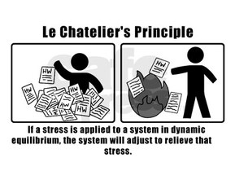

**TOPIC 1:**   
EQUILIBRIUM

Syllabus dot-points

**Science Understanding:**

* collision theory can be used to explain and predict the effects of concentration, temperature, pressure, the presence of catalysts and surface area of reactants on the rates of chemical reactions
* chemical systems include physical changes and chemical reactions and may be open (which allow matter and energy to be exchanged with the surroundings) or closed (which allow energy, but not matter, to be exchanged with the surroundings)
* observable changes in chemical reactions and physical changes can be described and explained at an atomic and molecular level
* over time, in a closed system, reversible physical and chemical changes may reach a state of dynamic equilibrium, with the relative concentrations of products and reactants defining the position of equilibrium
* the characteristics of a system in dynamic equilibrium can be described and explained in terms of reaction rates and macroscopic properties
* the reversibility of chemical reactions can be explained in terms of the activation energies of the forward and reverse reactions
* the effects of changes in temperature, concentration of species in solution, partial pressures of gases, total volume and the addition of a catalyst on equilibrium systems can be predicted using Le Châtelier’s Principle
* the effects of changes in concentration of solutions and partial pressures of gases on chemical systems initially at equilibrium can be predicted and explained by applying collision theory to the forward and reverse reactions
* the effect of changes of temperature on chemical systems initially at equilibrium can be predicted by considering the enthalpy changes for the forward and reverse reactions; this can be represented on energy profile diagrams and explained by the changes in the rates of the forward and reverse reactions
* equilibrium law expressions can be written for homogeneous and heterogeneous systems; the equilibrium constant (K), at any given temperature, indicates the relationship between product and reactant concentrations at equilibrium
* the relative amounts of reactants and products (equilibrium position) can be predicted qualitatively using equilibrium constants (Kc)
* reagents and reaction conditions are chosen to optimise yield and rate for chemical synthesis processes, including in the production of ammonia (Haber process), sulfuric acid (Contact process)

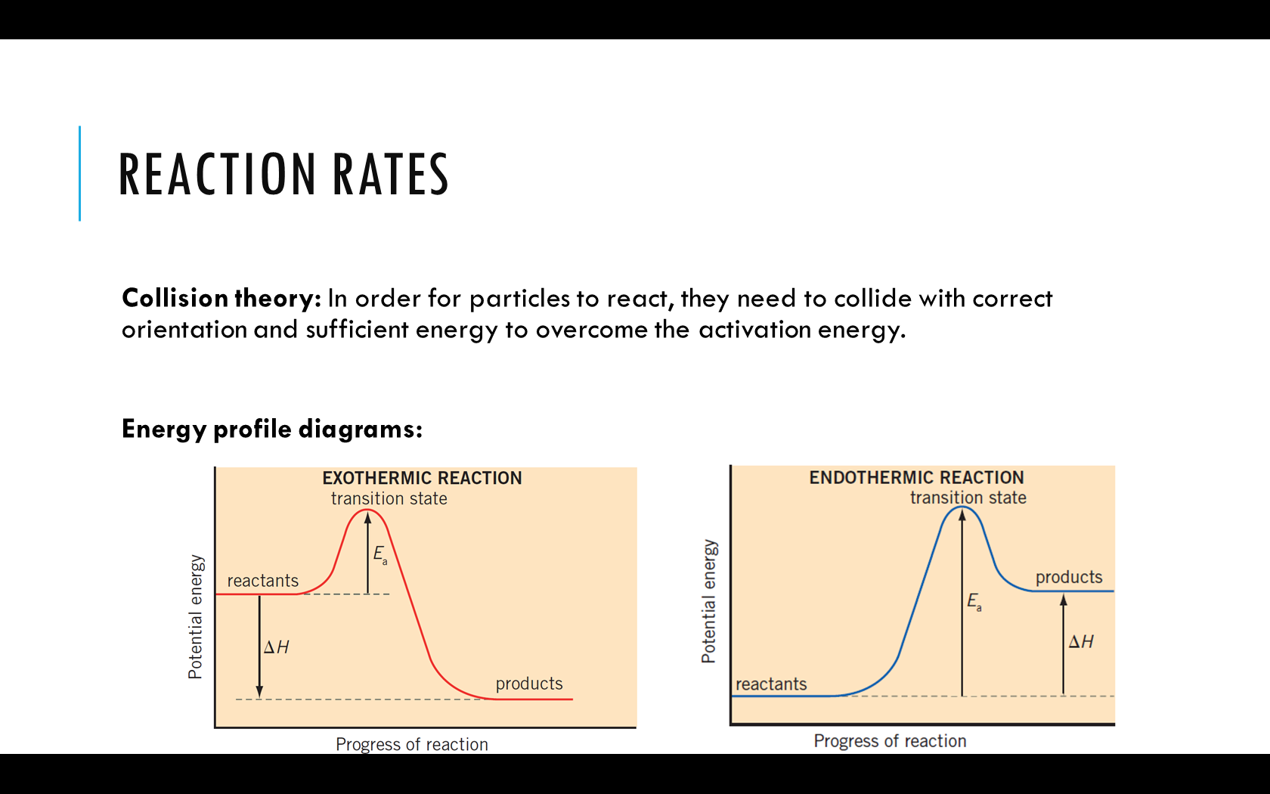

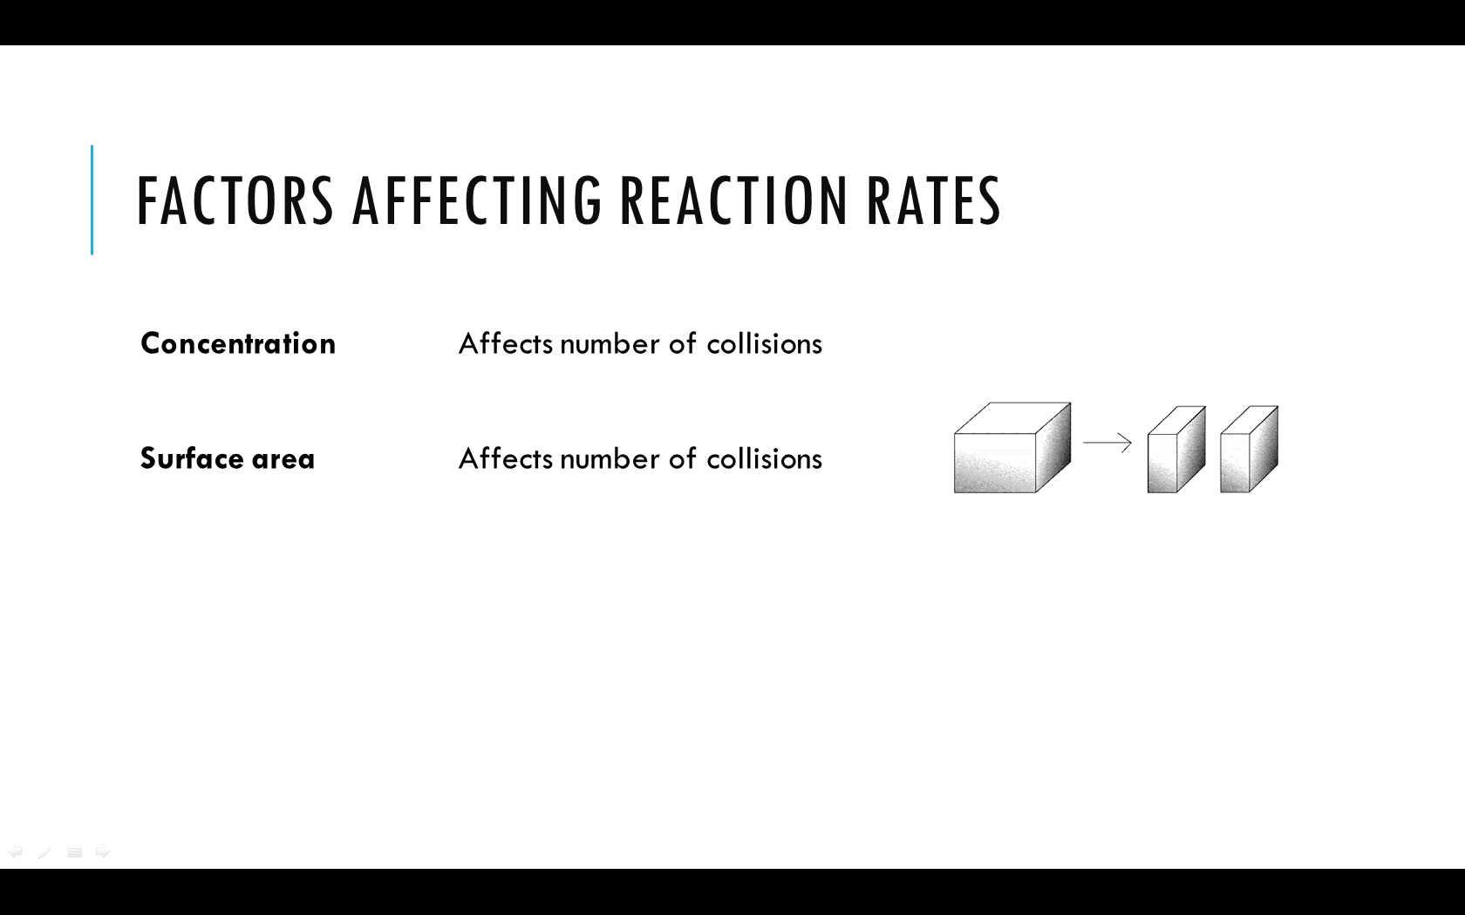

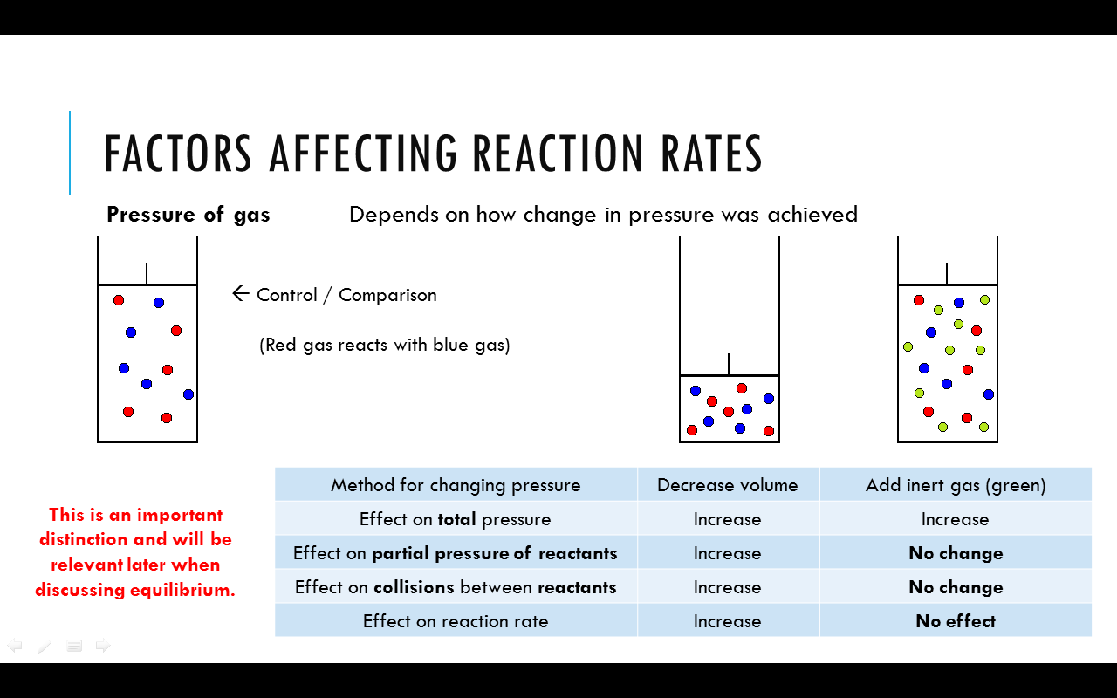

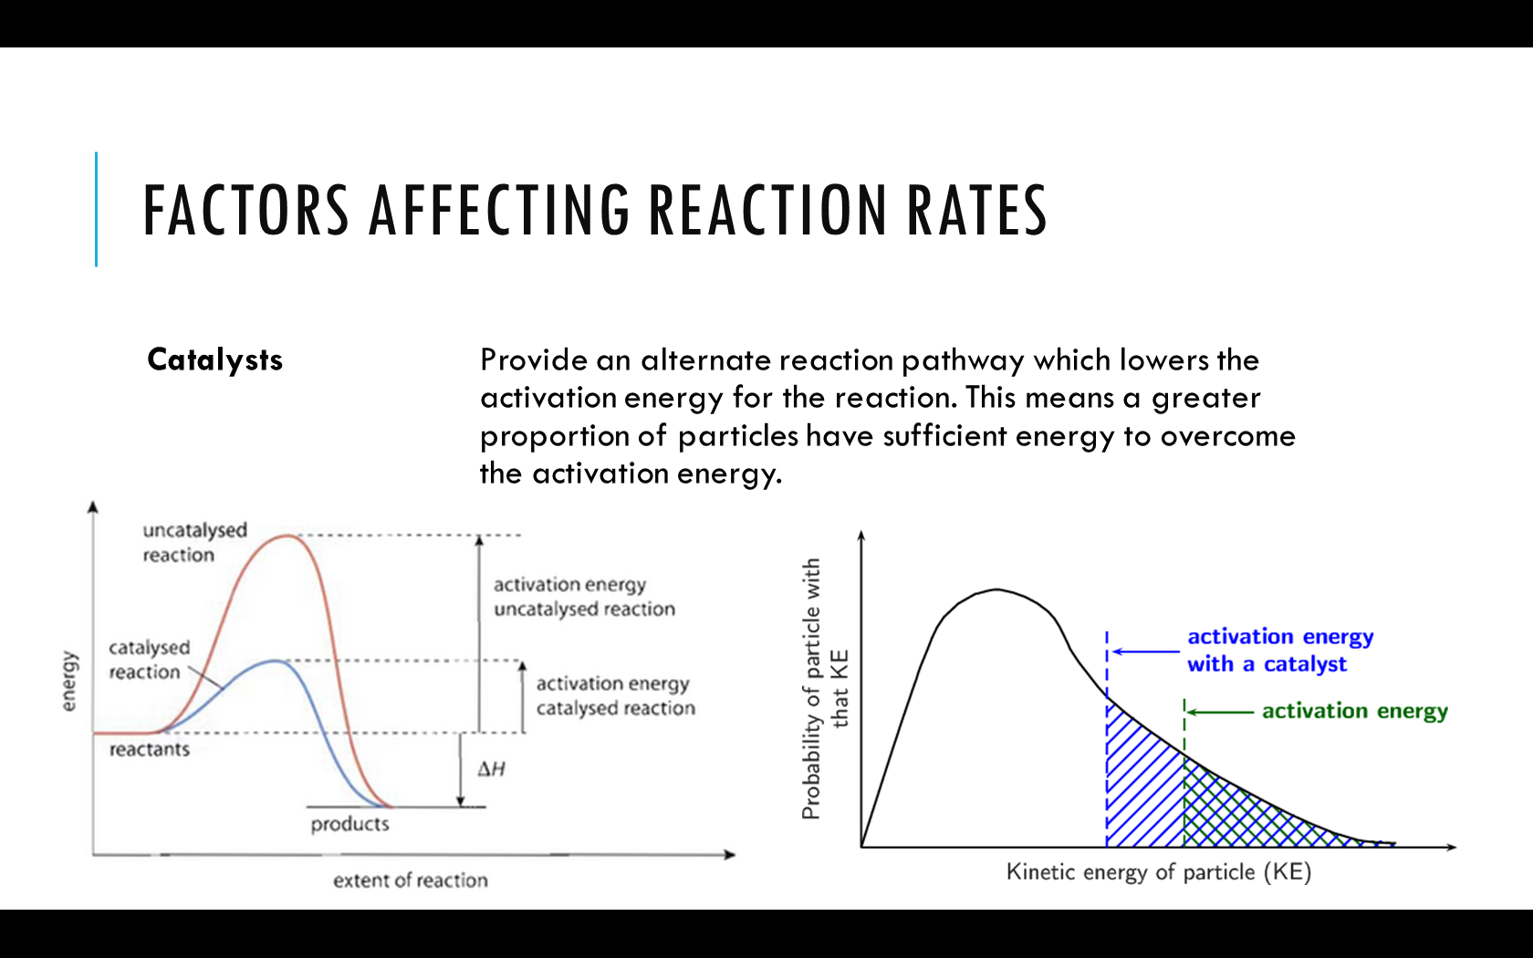

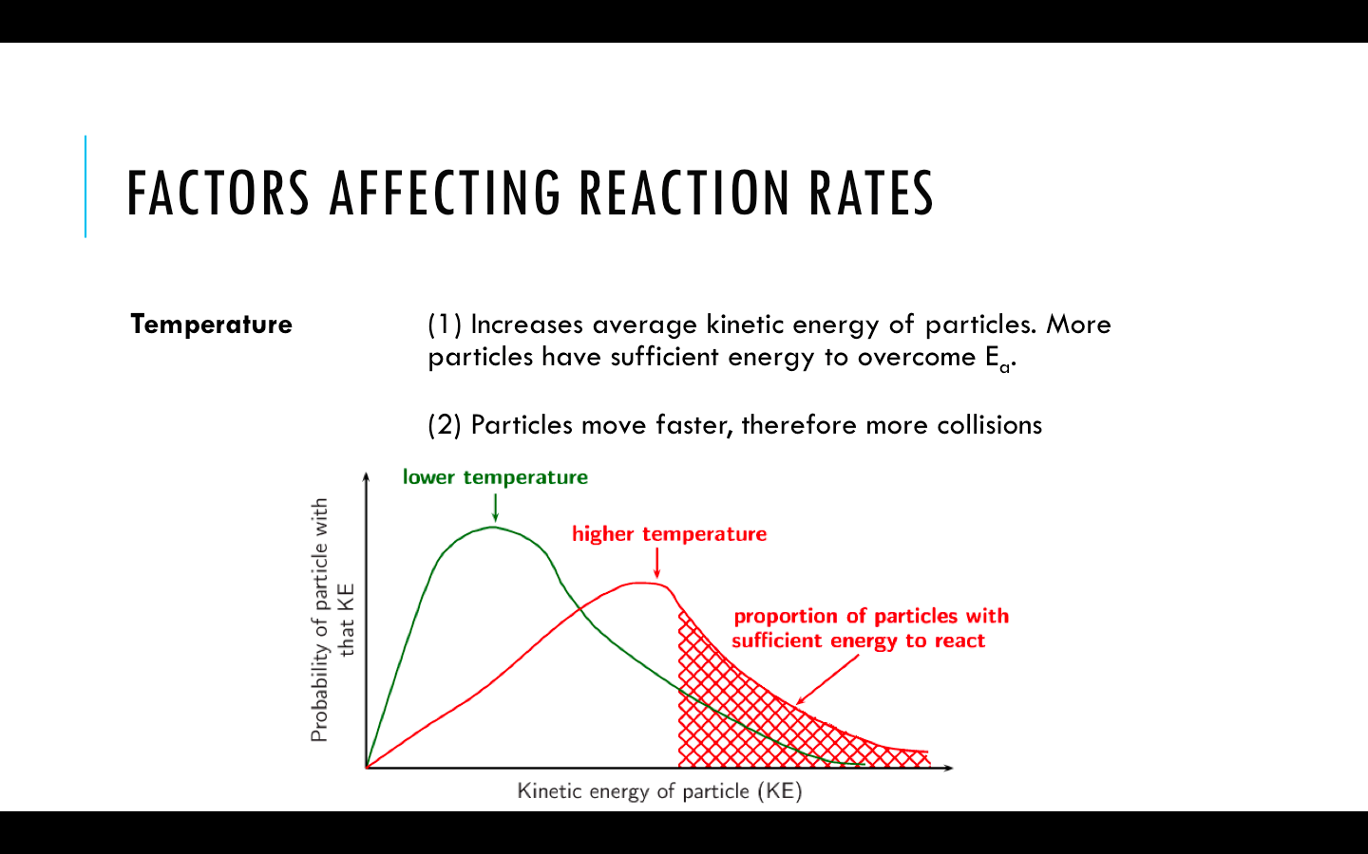

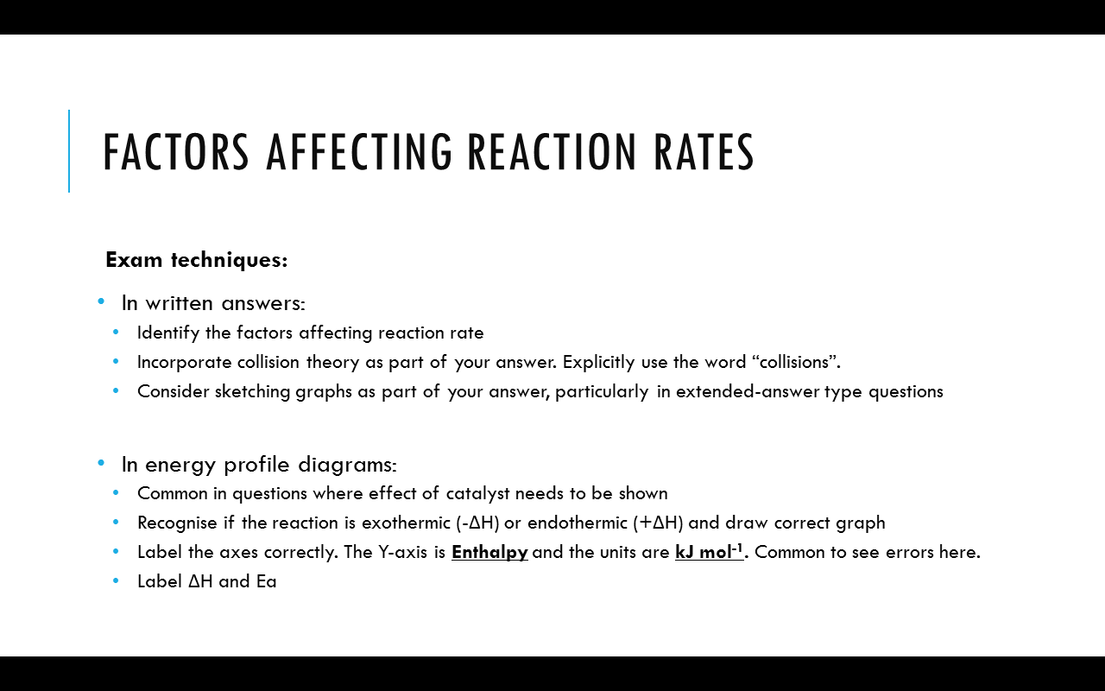

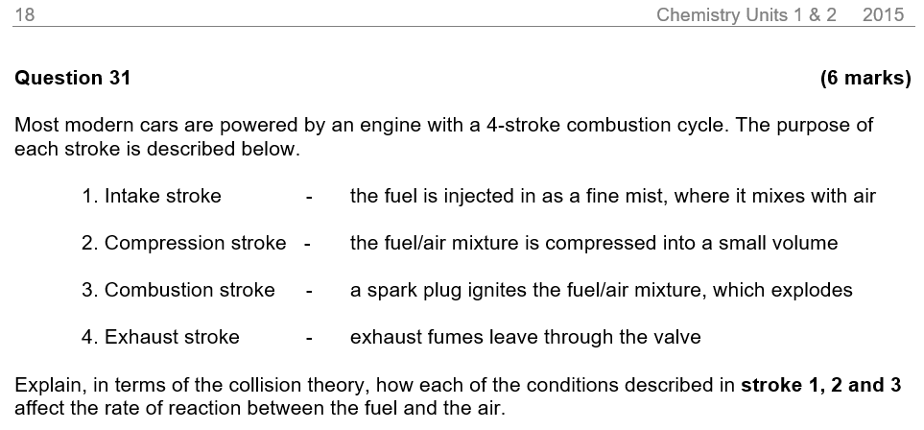



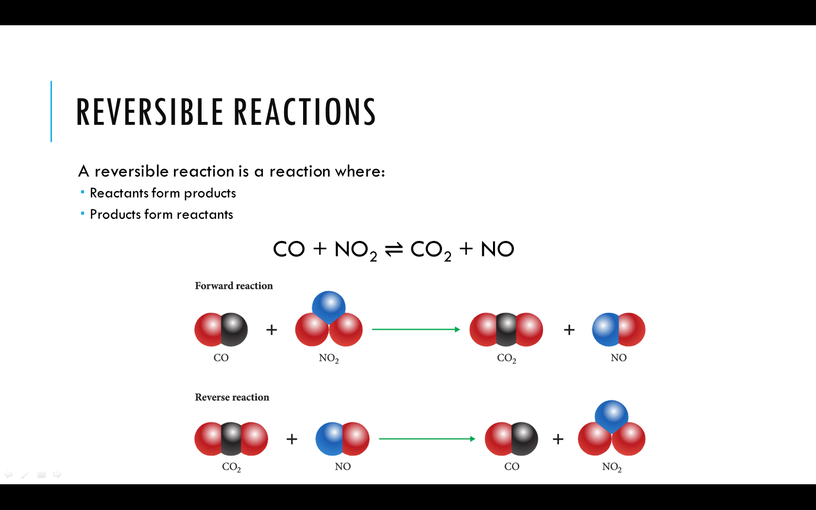



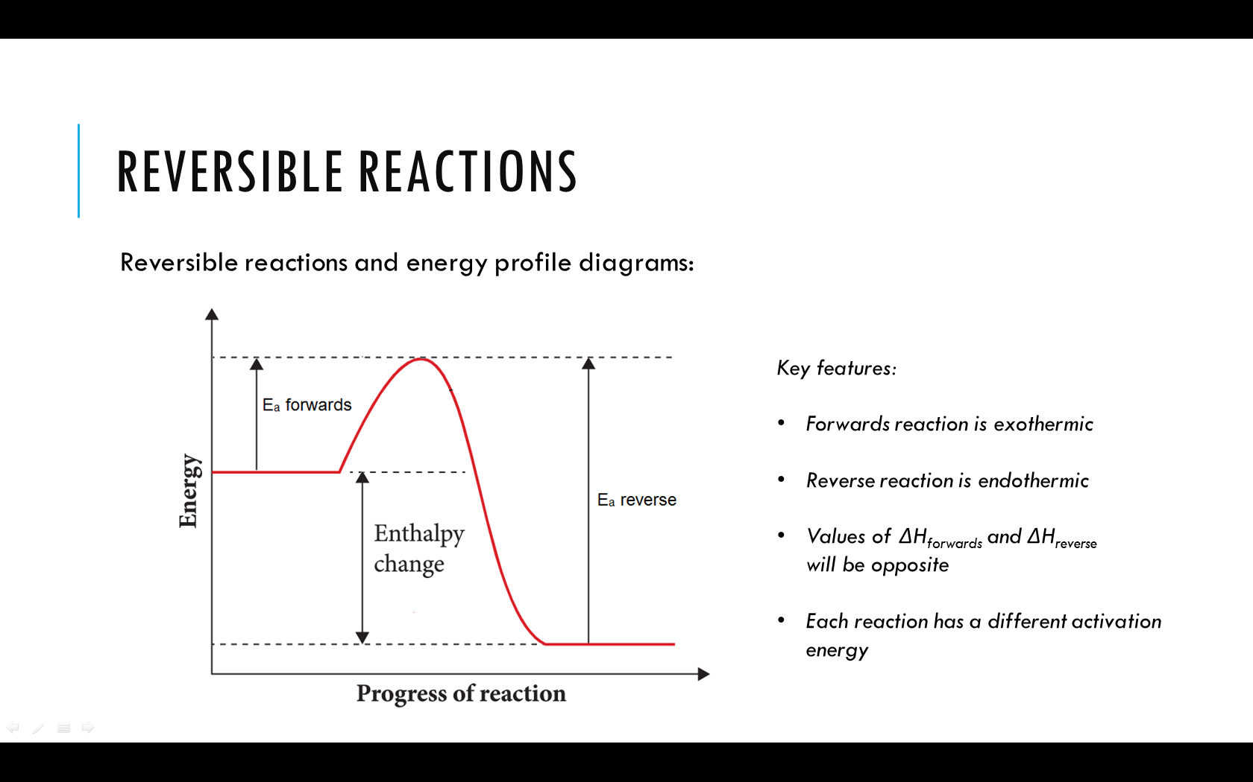

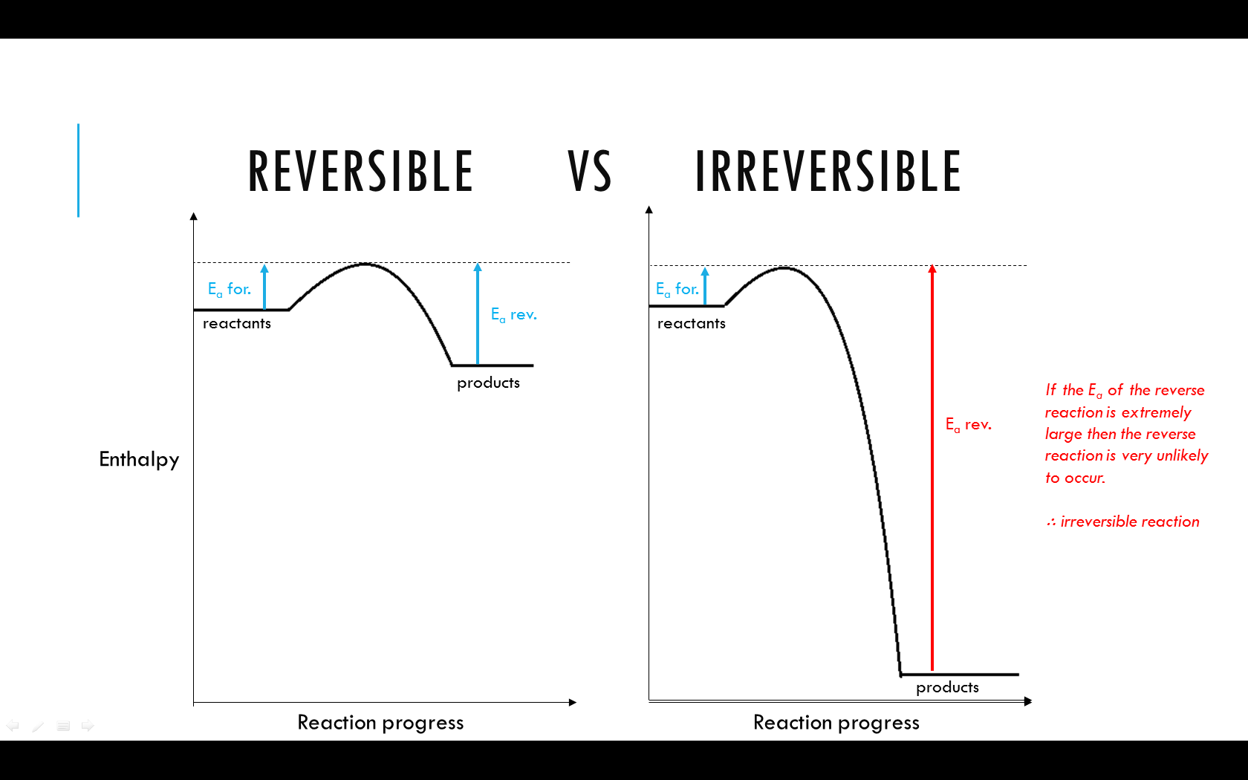

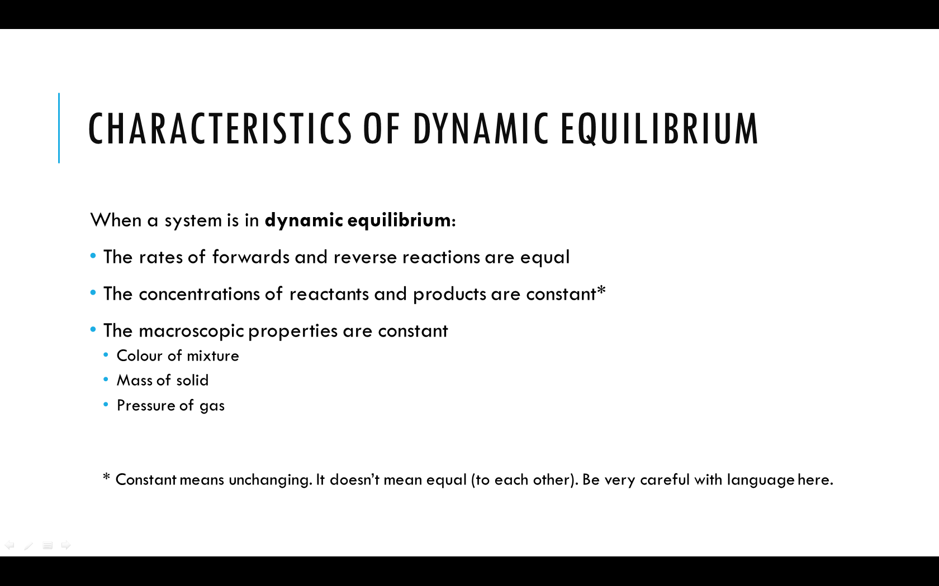

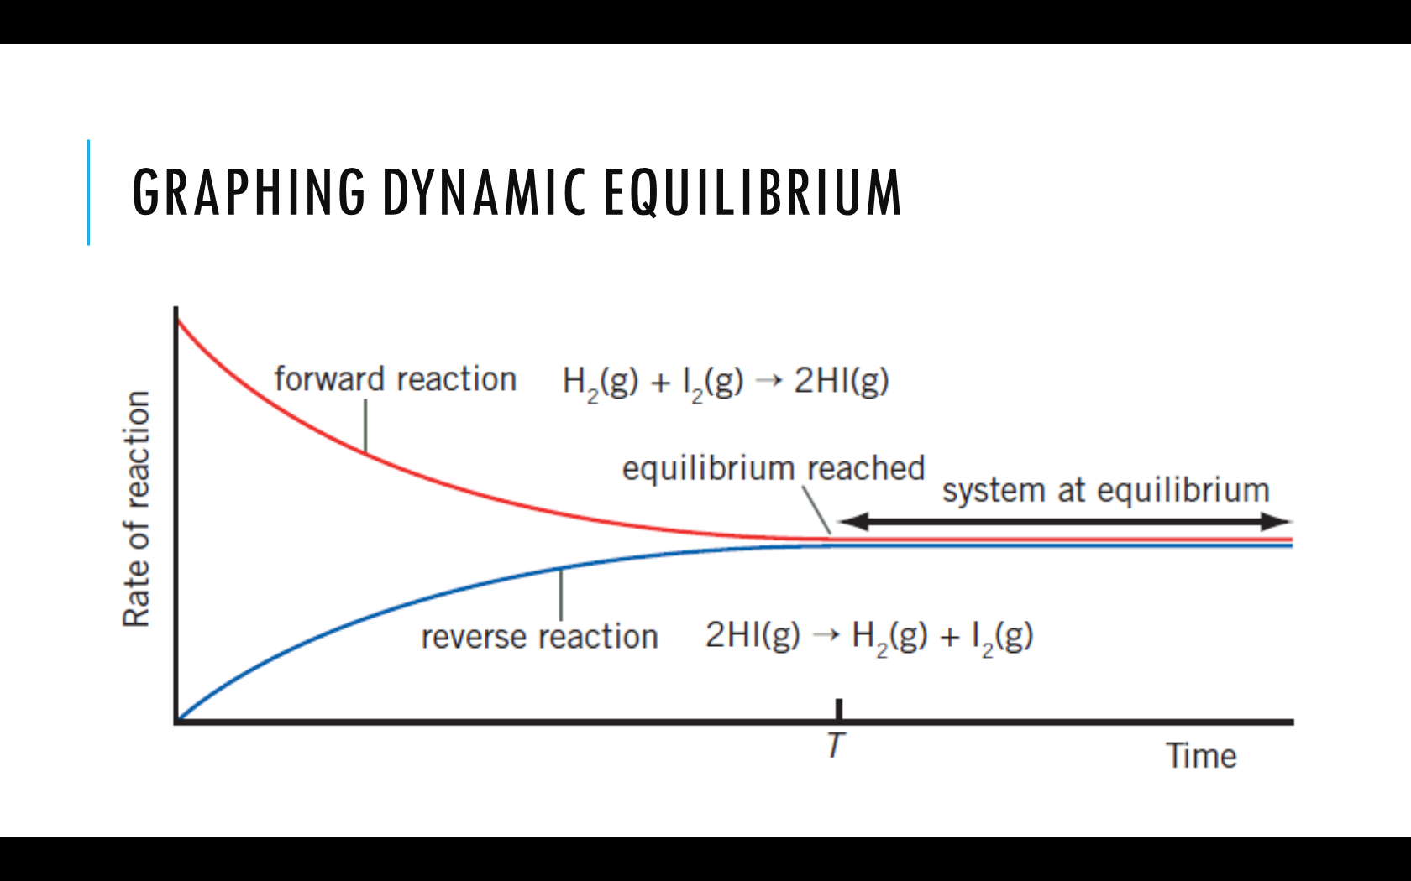

**  
**Explain, using collision theory, what is happening in the system on the left from time=0 to time=T.

Explain the shape of the graph after time=T.

Measure (in cm) the height that the following concentration lines decreased or increased from time=0 to time=T.

* Decrease in [I2] = ______________ cm *Note: square brackets is shorthand for concentration. [I2] means “concentration of I2”*
* Decrease in [H2] = ______________ cm
* Increase in [HI] = ______________ cm

Why do [I2] and [H2] decrease at the same rate as each other?

What is significant about the increase in [HI] relative to the decrease in [I2] and [H2]? How can this be explained?

HI(g) and H2(g) are both colourless, and I2(g) is purple. What would be observed in this mixture throughout the different stages of the experiment? Justify your answer.

**Sample Questions**

**2008 TEE Exam (Question 22):**

Consider the following system, which is at equilibrium:

C2H4(g) + HCℓ(g) ⇌ CH3CH2Cℓ(g) ΔH = -70 kJ mol-1

Which one of the following statements about the system is true?

1. The rate of the forward reaction and the rate of the reverse reaction are zero?
2. The concentrations of the reactants will remain constant over time
3. The concentration of C2H4 will equal the concentration of CH3CH2Cℓ
4. The sum of the concentrations of C2H4 and HCℓ will equal the concentration of CH3CH2Cℓ

**2011 WACE Exam (Question 12):**

Which of the following properties are characteristic of a gaseous system in dynamic chemical equilibrium?

1. The concentrations of reactants are equal to the concentration of products
2. The concentrations of reactants and products are constant
3. The rate of the forward reaction is equal to the rate of the reverse reaction
4. The pressure of the system is constant
5. (i), (ii) and (iii)
6. (i), (ii) and (iv)
7. (ii), (iii) and (iv)
8. (iii) only

**Misc. question:**

The graph below shows the change in concentration for gases present over a period of time for the reaction that occurs when sulfur dioxide is burnt in oxygen in a closed system.

Reaction: 2 SO2 + O2 ⇌ 2 SO3; ΔH = -99 kJ mol-1

0 1 2 3 4 5 6 7 8 9 10 min

C

B

A

concentration

1. Identify which substances are represented by the lines… A: ________ B: ________ C: _________
2. At what point was equilibrium reached? _______________________________

Justify your answer. ___________________________________________________________________________________

____________________________________________________________________________________________________

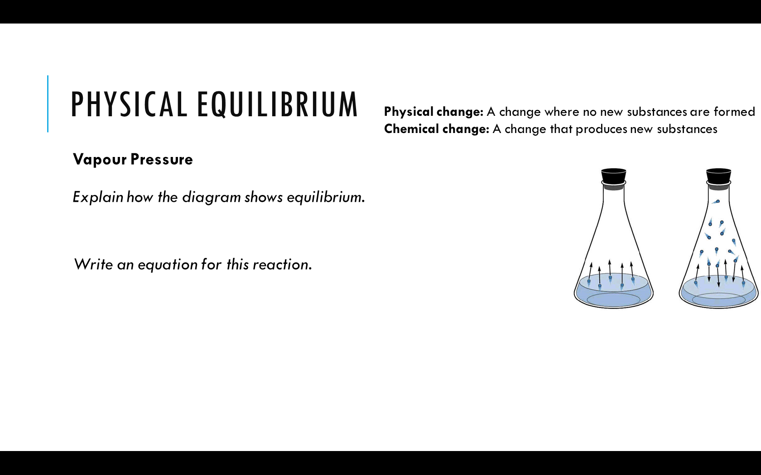

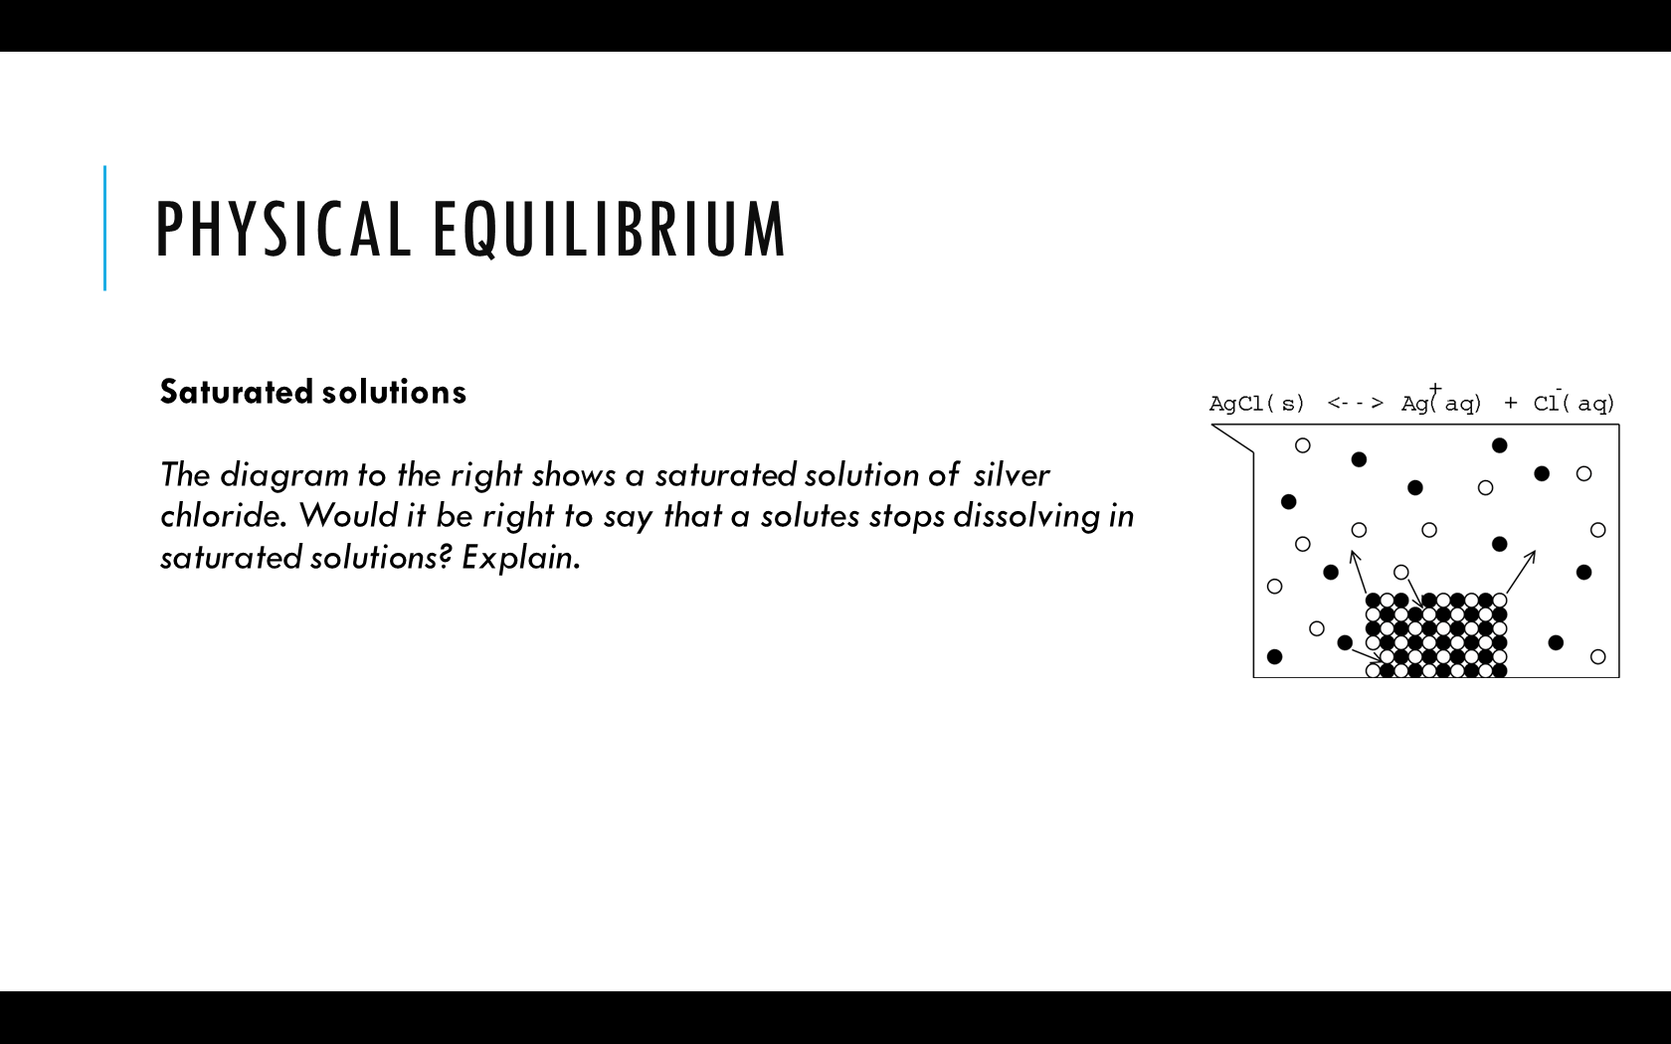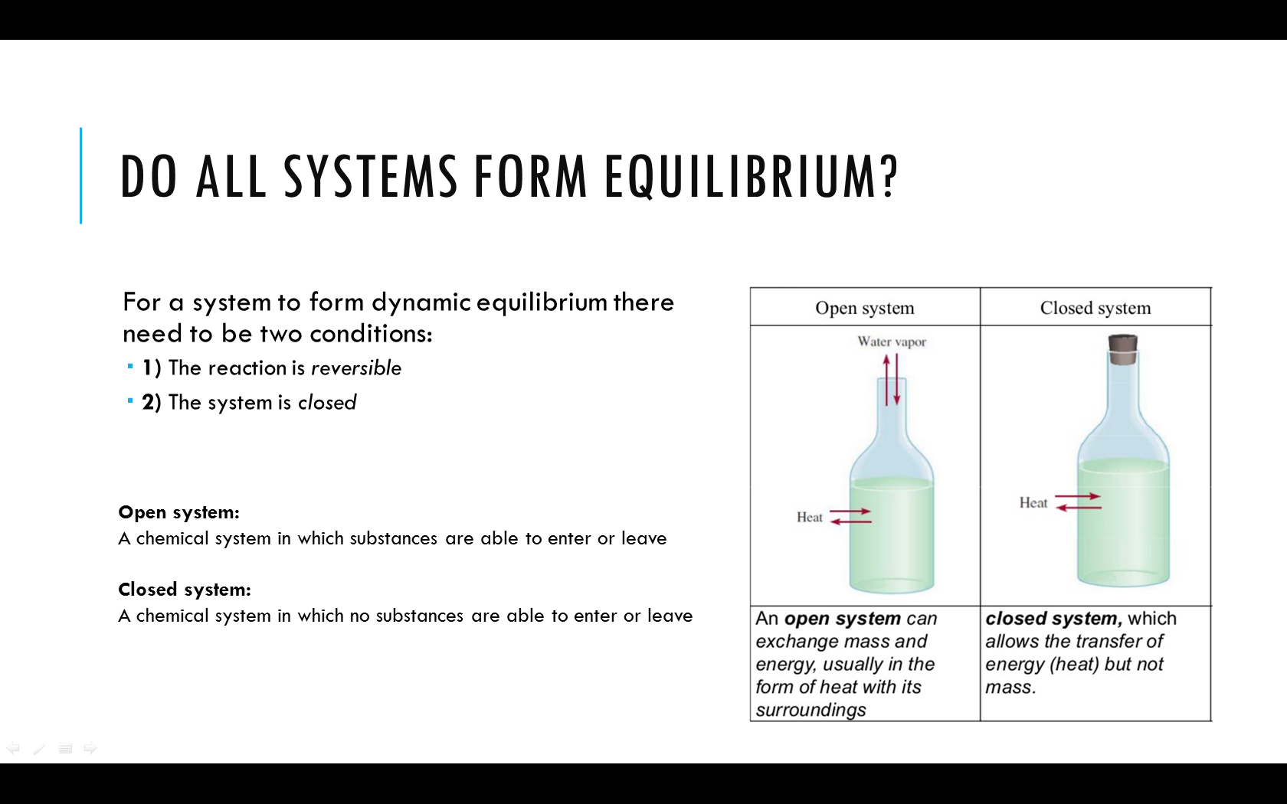

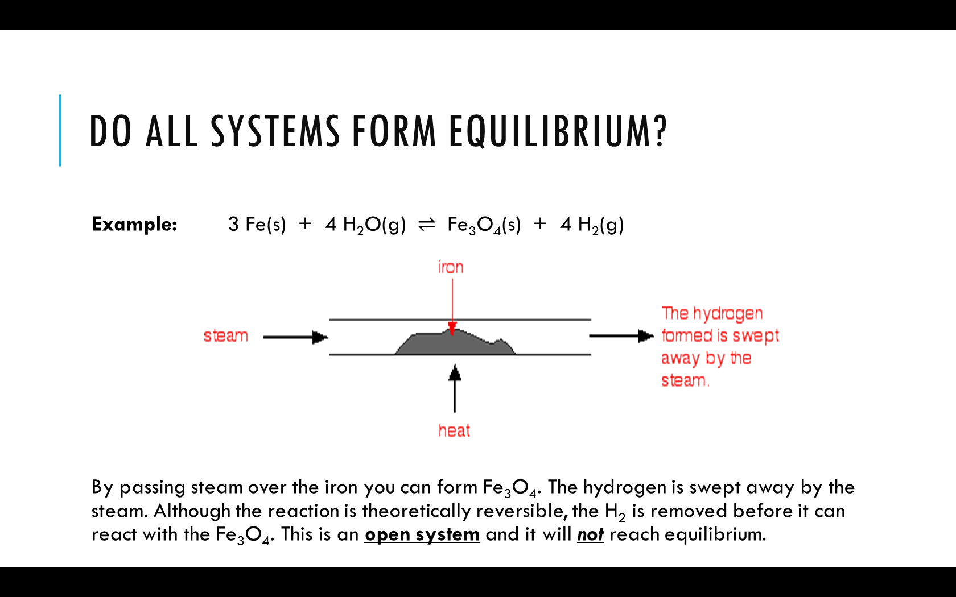

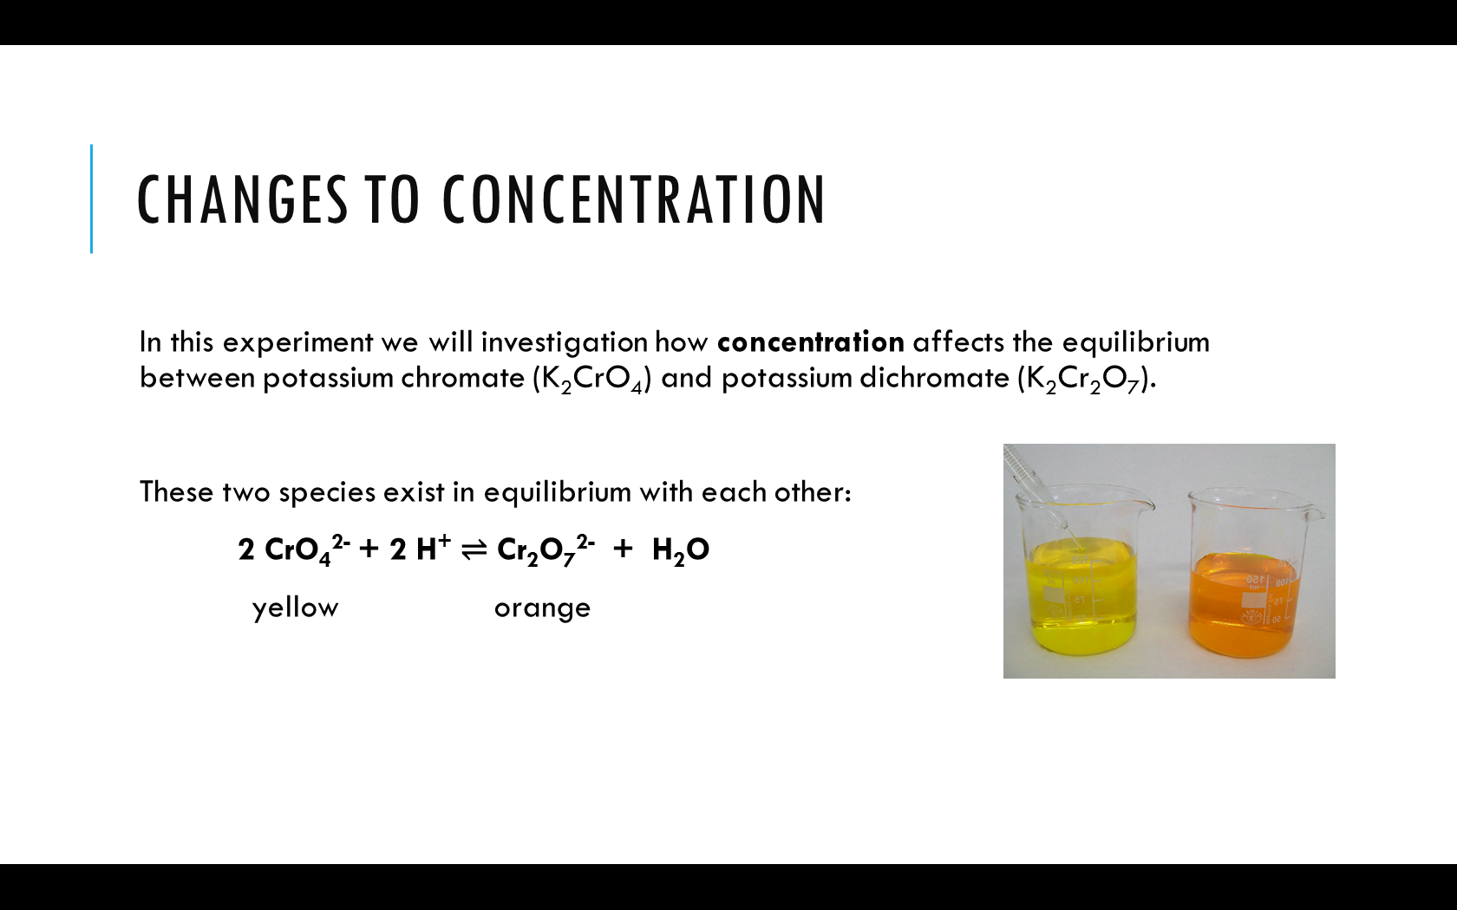

***Method:***

1. Place about 1 mL of 0.1 mol L-1 K2CrO4 into each of two test tubes and note the colour of the solution. Use one of the test tubes for comparison of colours.
2. Place about 1 mL of 0.1 mol L-1 K2Cr2O7 into each of two test tubes and note the colour of the solution. Use one of the test tubes for comparison of colours.

*Reactions of potassium chromate:*

1. To one of the test tubes of KCrO4 add 0.2 mol L-1 HCℓ dropwise until a colour change is noted
2. To the same solution now add 0.2 mol L-1 NaOH dropwise until another colour change is noted.

*Reactions of potassium dichromate:*

1. To one of the test tubes of K2Cr2O7 add 0.2 mol L-1 NaOH dropwise until a colour change is observed.
2. To the same solution now add 0.2 mol L-1 HCℓ dropwise until another colour change is noted.

***Results:***

|  |  |  |  |
| --- | --- | --- | --- |
| **Initial solution** | **Change** | **Observation** | **Inference** |
| Potassium chromate (K2CrO4) | Add HCℓ |  |  |
| then add NaOH |  |  |
| Potassium dichromate (K2Cr2O7) | Add NaOH |  |  |
| then add HCℓ |  |  |

***Question:***

What evidence is there that the system is in dynamic equilibrium prior to adding HCℓ or NaOH?  
  
  
  
What evidence is there that adding HCℓ or NaOH temporarily disrupts equilibrium?

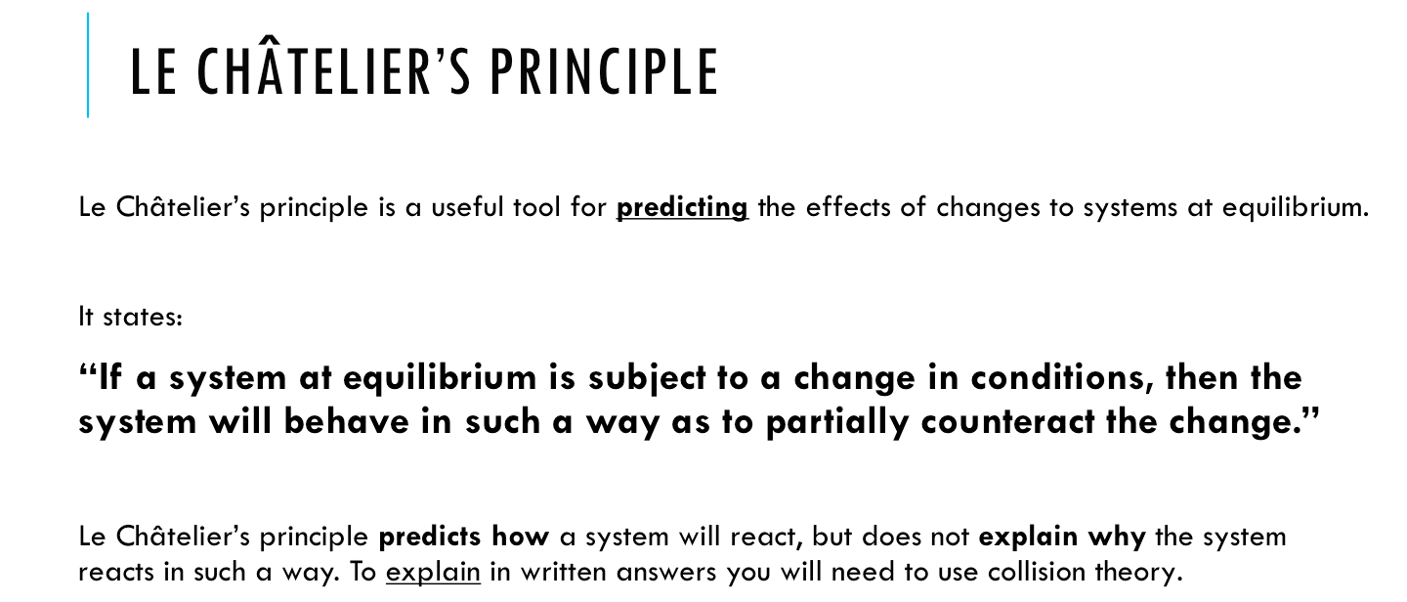

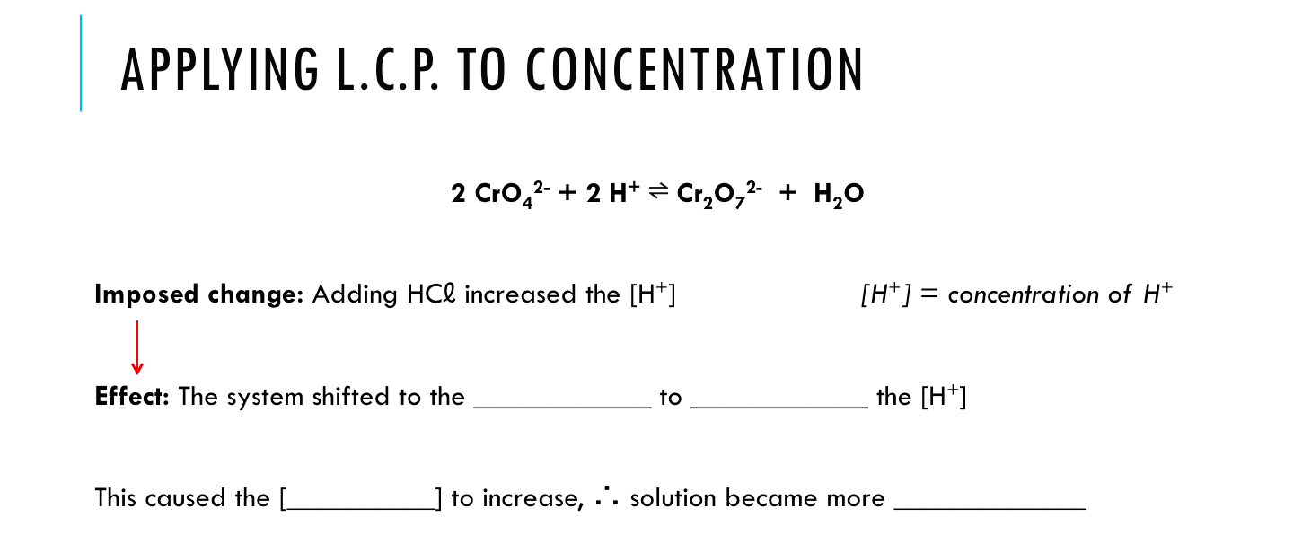

ORANGE/YELLOW

INCREASE/DECREASE

LEFT/RIGHT

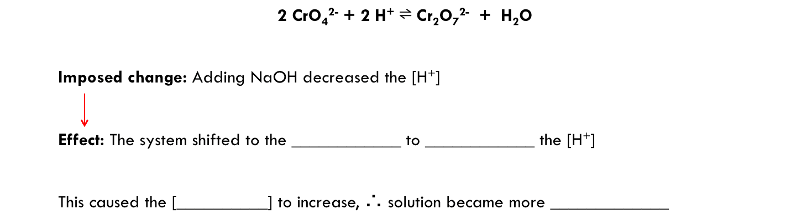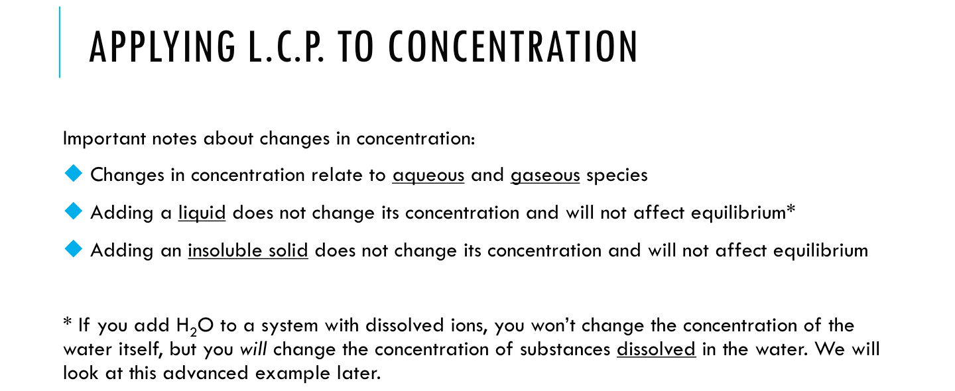

LEFT/RIGHT

INCREASE/DECREASE

ORANGE/YELLOW

Complete the following tables for the changes shown. For each change show:

* the direction of shift (*left, right* or *no change)*
* a comparison of the concentration of species at the new equilibrium compared to the old equilibrium *(increased, decrease* or *no change)*

|  |  |  |  |  |  |
| --- | --- | --- | --- | --- | --- |
| **Equation:** | Fe3+(aq) + SCN-(aq) ⇌ FeSCN2+(aq) pale yellow clear reddish-brown | | | |  |
| **Change** | **Direction of shift** | **Concentration of species at new equilibrium** | | | **Observations** |
| **Fe3+** | **SCN-** | **FeSCN2+** |
| Add some  additional Fe3+(aq) |  |  |  |  |  |

|  |  |  |  |  |  |
| --- | --- | --- | --- | --- | --- |
| **Equation:** | Fe3+(aq) + SCN-(aq) ⇌ FeSCN2+(aq) pale yellow clear reddish-brown | | | |  |
| **Change** | **Direction of shift** | **Concentration of species at new equilibrium** | | | **Observations** |
| **Fe3+** | **SCN-** | **FeSCN2+** |
| Add some  additional SCN-(aq) |  |  |  |  |  |

|  |  |  |  |  |  |
| --- | --- | --- | --- | --- | --- |
| **Equation:** | Fe3+(aq) + SCN-(aq) ⇌ FeSCN2+(aq) pale yellow clear reddish-brown | | | |  |
| **Change** | **Direction of shift** | **Concentration of species at new equilibrium** | | | **Observations** |
| **Fe3+** | **SCN-** | **FeSCN2+** |
| Add some F-  reacts with Fe3+ to form FeF63- |  |  |  |  |  |

|  |  |  |  |  |  |
| --- | --- | --- | --- | --- | --- |
| **Equation:** | 3 Cu(s) + 2 NO3-(aq) + 8 H+(aq) ⇌ 3 Cu2+(aq) + 2 NO(g) + 4 H2O(ℓ) | | | | |
| **Change** | **Direction of shift** | **Concentration of species at new equilibrium** | | | |
| **[NO3-]** | **[H+]** | **[Cu2+]** | **[NO]** |
| Add some concentrated HCℓ |  |  |  |  |  |

|  |  |  |  |  |  |
| --- | --- | --- | --- | --- | --- |
| **Equation:** | 3 Cu(s) + 2 NO3-(aq) + 8 H+(aq) ⇌ 3 Cu2+(aq) + 2 NO(g) + 4 H2O(ℓ) | | | | |
| **Change** | **Direction of shift** | **Concentration of species at new equilibrium** | | | |
| **[NO3-]** | **[H+]** | **[Cu2+]** | **[NO]** |
| Dissolve some CuSO4(s) |  |  |  |  |  |

|  |  |  |  |  |  |
| --- | --- | --- | --- | --- | --- |
| **Equation:** | 3 Cu(s) + 2 NO3-(aq) + 8 H+(aq) ⇌ 3 Cu2+(aq) + 2 NO(g) + 4 H2O(ℓ) | | | | |
| **Change** | **Direction of shift** | **Concentration of species at new equilibrium** | | | |
| **[NO3-]** | **[H+]** | **[Cu2+]** | **[NO]** |
| Add 5 drops of concentrated KOH |  |  |  |  |  |

|  |  |  |  |  |  |
| --- | --- | --- | --- | --- | --- |
| **Equation:** | 3 Cu(s) + 2 NO3-(aq) + 8 H+(aq) ⇌ 3 Cu2+(aq) + 2 NO(g) + 4 H2O(ℓ) | | | | |
| **Change** | **Direction of shift** | **Concentration of species at new equilibrium** | | | |
| **[NO3-]** | **[H+]** | **[Cu2+]** | **[NO]** |
| Add more copper metal to the container |  |  |  |  |  |

|  |  |  |  |  |  |
| --- | --- | --- | --- | --- | --- |
| **Equation:** | 3 Cu(s) + 2 NO3-(aq) + 8 H+(aq) ⇌ 3 Cu2+(aq) + 2 NO(g) + 4 H2O(ℓ) | | | | |
| **Change** | **Direction of shift** | **Concentration of species at new equilibrium** | | | |
| **[NO3-]** | **[H+]** | **[Cu2+]** | **[NO]** |
| Open the container to let out the NO(g) and then close it again |  |  |  |  |  |

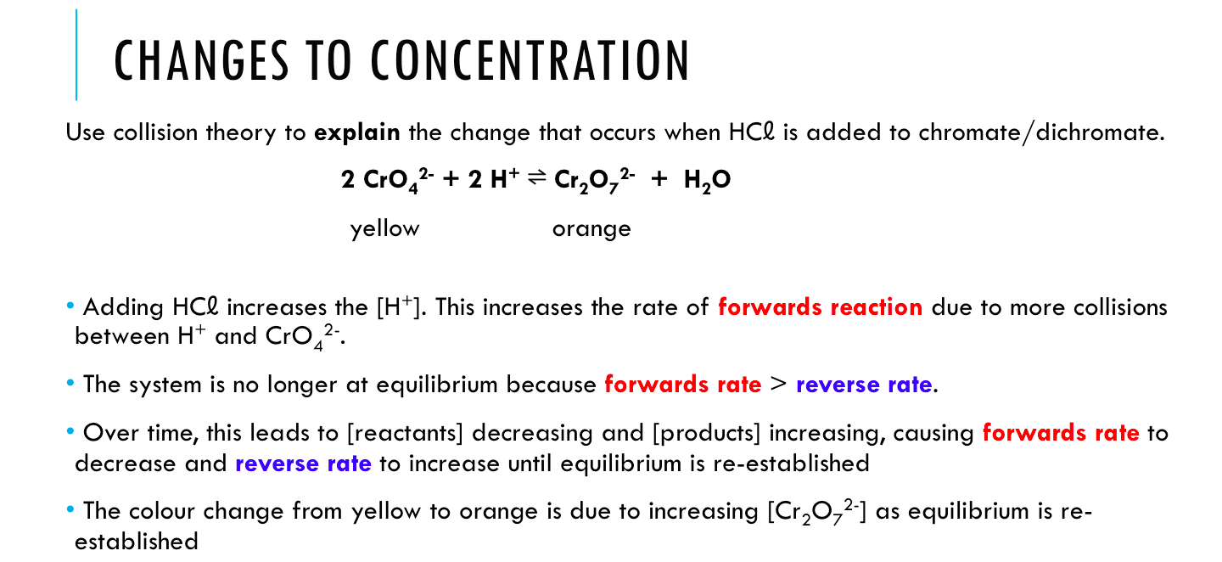

**These changes can be represented using concentration-time and rate-time graphs.**

**Pay attention to the following:**

* There is an initial change (sudden spike in [H+]) followed by a change over time as equilibrium is re-established
* The concentration of H+ only partially decreases as equilibrium is restored. It doesn’t reach its original value.
* The graph shows the correct **mole ratio**. The H+ and CrO42- lines decrease twice as much as Cr2O72- increases.
* The graph curves need to be to correct shape. They start of steep and then go shallower as it gets closer to equilibrium.

Reaction rates

Concentration

H+

CrO42- (yellow)

Cr2O72- (orange)

Forwards reaction rate

Reverse reaction rate

HCℓ added

Equilibrium re-established

Equilibrium re-established

HCℓ added

time

time

**Addition of NaOH to potassium dichromate solution. 2 CrO42- + 2 H+ ⇌ Cr2O72- + H2O**

**Explain** the colour change observed when NaOH was added to the potassium dichromate solution. Include a diagram of concentration and reaction rates as part of your answer.

time

time

**Order for drawing the graphs:**

1. What is the **initial** change in concentration?
2. What is the **initial** (immediate) effect of this change on forward **and/or** reverse reaction rate?
3. What will happen to the forward and reverse reaction rates as equilibrium is re-established?
4. What will happen to the concentrations of the reactants and products as equilibrium is re-established? *(Hint: Look at which reaction rate is faster in the graph underneath…)*
5. Double check mole ratios and curve shapes.

Reaction rates

Concentration

H+

CrO42- (yellow)

Cr2O72- (orange)

Forwards reaction rate

Reverse reaction rate

NaOH added

Equilibrium re-established

Equilibrium re-established

NaOH added

**Changes to Concentration:**

Fe3+(aq) + SCN–(aq) ⇌ FeSCN2+(aq)

**(colourless)** **(red)**

A solution of Fe3+/SCN–/FeSCN2+ is initially at equilibrium. The solution is a pale red colour.   
**Explain** what would happen if a soluble salt containing **FeSCN2+ ions** was added to the water.

time

time

Reaction rates

Concentration

FeSCN2+

Fe3+

SCN-

Forwards reaction rate

Reverse reaction rate

FeSCN2+ added

Equilibrium re-established

Equilibrium re-established

FeSCN2+ added

HCℓ added

**Changes to Concentration:**

Fe3+(aq) + SCN-(aq) ⇌ FeSCN2+(aq)

**(colourless)** **(red)**

A solution of Fe3+/SCN-/FeSCN2+ is initially at equilibrium. The solution is a pale red colour.   
**Explain** what would happen if drops of concentrated **potassium hydroxide** were added to the water.

time

time

Reaction rates

Concentration

FeSCN2+

Fe3+

SCN-

Forwards reaction rate

Reverse reaction rate

KOH added

Equilibrium re-established

Equilibrium re-established

KOH added

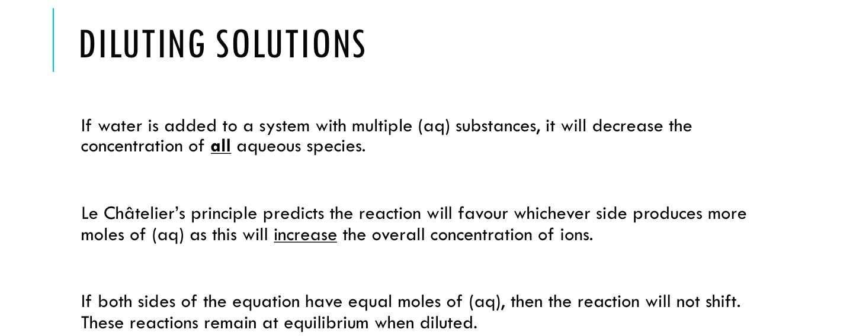

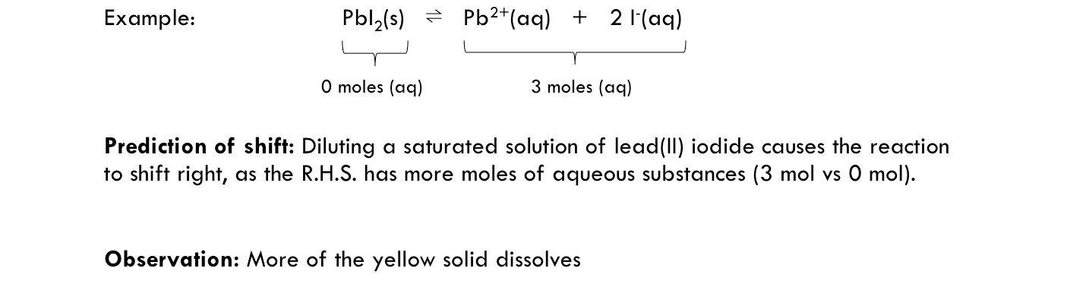

**Predict how the following systems would be affected by addition of water:**

|  |  |  |  |
| --- | --- | --- | --- |
| **Reaction** | **Moles of aqueous substances** | | **Direction of shift when diluted** |
| **L.H.S.** | **R.H.S.** |
| Fe3+(aq) + SCN-(aq) ⇌ FeSCN2+(aq) |  |  |  |
| [Cu(H2O)6]2+(aq) + 4 Cℓ-(aq) ⇌ [CuCℓ4]2-(aq) + 6 H2O(ℓ) |  |  |  |
| CH3COOH(aq) ⇌ CH3COO-(aq) + H+(aq) |  |  |  |
| H2O(ℓ) ⇌ H2O(g) |  |  |  |
| CO2(g) + NaOH(aq) ⇌ NaHCO3(aq) |  |  |  |
| Cu(s) + 2 Ag+(aq) ⇌ Cu2+(aq) + 2 Ag(s) |  |  |  |
| 2 FeCℓ3(aq) + SnCℓ2(aq) ⇌ 2 FeCℓ2(aq) + SnCℓ4(aq) |  |  |  |

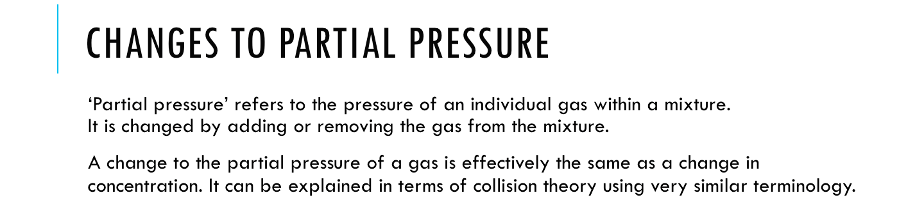

**Example:**

The reaction between carbon and hydrogen gas to form methane can be presented by the following equation.

C(s) + 2 H2(g) ⇌ CH4(g) + 75 kJ

The concentrations of hydrogen and methane were plotted over time and the following graph produced.



Q: At what time did the reaction (first) reach equilibrium? Justify your answer.

Q: What could have caused the change at occurred after 25 minutes?

Q: Explain the change in shape from t=25 to t=45.

**Changes to Partial Pressure:** I2(g) + H2(g) ⇌ 2 HI(g)

**(purple)** **(colourless)**

Use **collision theory** to **explain** the changes that occur when additional I2(g) is added to the container.

time

time

Reaction rates

Pressure

Forwards reaction rate

Reverse reaction rate

I2(g) added

Equilibrium re-established

Equilibrium re-established

I2(g) added

Describe observations for the system over this time period.

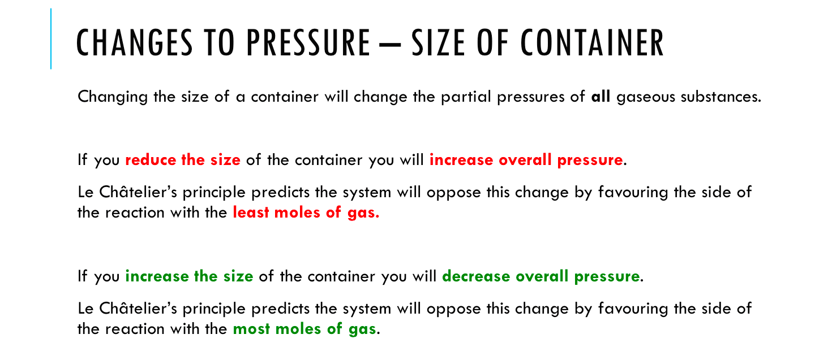

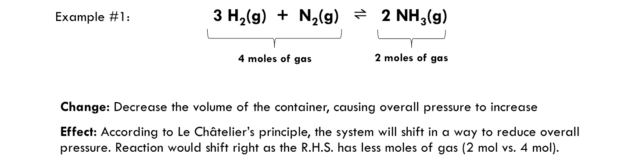

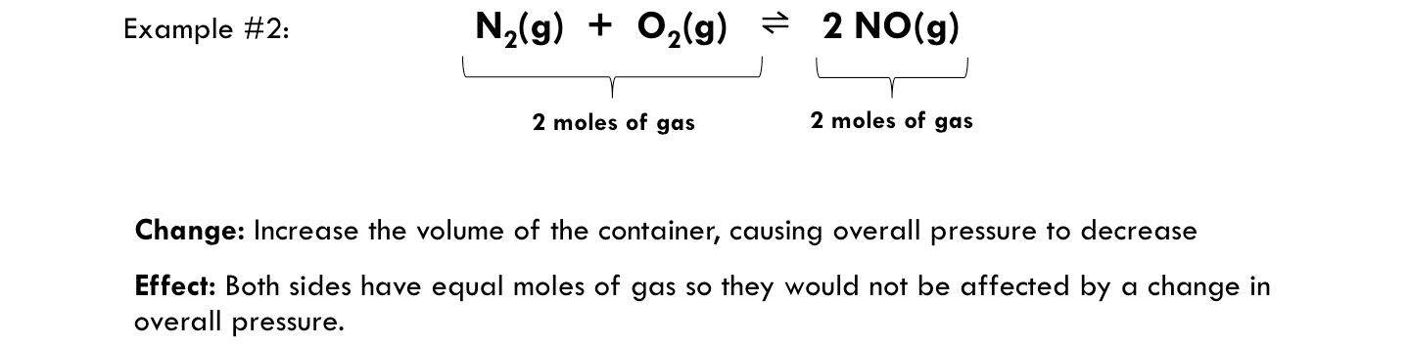

**Complete the table:**

|  |  |  |
| --- | --- | --- |
| **Reaction** | **Imposed change** | **Shift in equilibrium** |
| CO(g) + H2O(g) ⇌ CO2(g) + H2(g) | Decrease volume |  |
| H2(g) + I2(g) ⇌ 2 HI(g) | Increase volume |  |
| 2 C2H4(g) + 2 H2O(g) ⇌ 2 C2H6(g) + O2(g) | Increase volume |  |
| Ti(s) + 2 Cℓ2(g) ⇌ TiCℓ4(g) | Decrease volume |  |

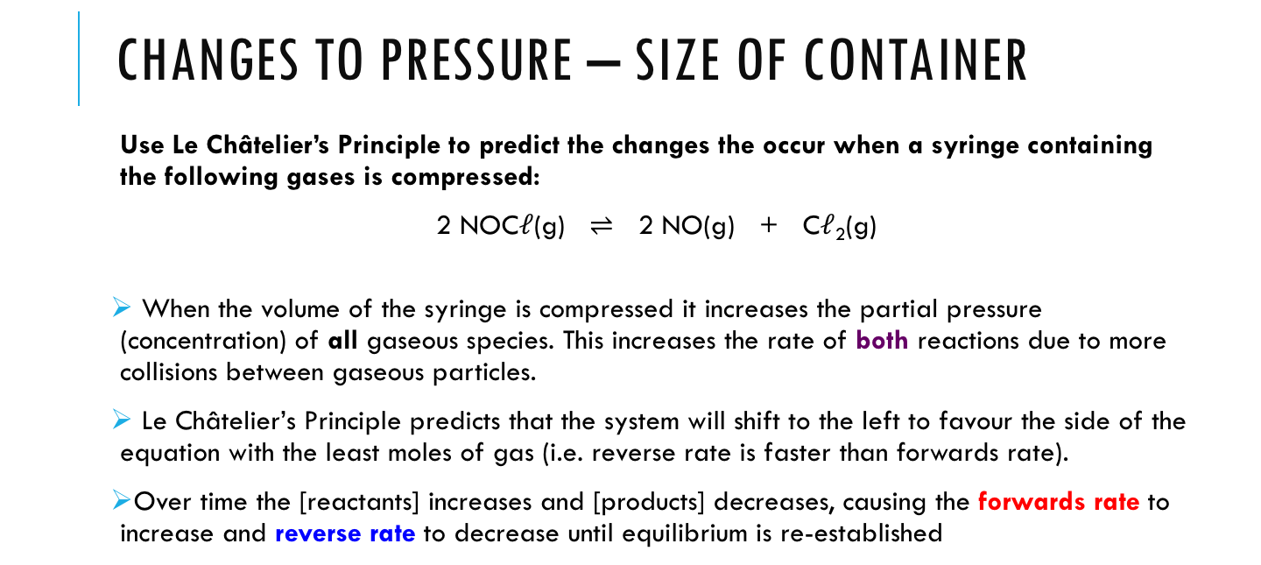

**Pay attention to the following:**

* Unlike the concentration graphs, a change in volume causes an **instant change** in the concentration of **all** gases. Think carefully about whether the change will increase or decrease **concentration**.   
  “Increase in volume” =   
  “Decrease in concentration”
* The **initial** changes in conc. is **not** related to the mole ratio. In this example, all concentrations were **doubled** for the initial change (i.e.volume **halved**)
* If the forward and reverse reactions both involve gases then they will **both** be affected by a change in volume. i.e. **both** increase or **both** decrease instantly. Think about the direction of shift to figure out which increases or decreases more than the other. In this case LCP predicts reaction will shift right, so forward rate must increase more than reverse rate.

NOCℓ

Cℓ2

NO

Reaction rates

Concentration

Forwards reaction rate

Reverse reaction rate

Syringe   
compressed

Equilibrium re-established

Equilibrium re-established

Syringe compressed

**Changes to Pressure (volume of container):**

Use **Le Châtelier's Principle** to **predict** the changes that occur when a syringe containing the following gases is expanded to take up more volume. Include the expected observations.

2 NO2(g) ⇌ N2O4(g)

**(brown)** **(colourless)**

time

time

N2O4

NO2

Reaction rates

Concentration

Forwards reaction rate

Reverse reaction rate

Volume in syringe   
is **doubled**

Equilibrium   
re-established

Equilibrium  
 re-established

Volume in syringe  
 is **doubled**

**Changes to Pressure (volume of container):**

Use **Le Châtelier's Principle** to **predict** the changes that occur when a syringe containing the following gases is compressed. Include the expected observations.

I2(g) + H2(g) ⇌ 2 HI(g)

**(purple)** **(colourless)**

time

time

H2

I2

HI

Reaction rates

Concentration

Forwards reaction rate

Reverse reaction rate

Volume in syringe   
is **halved**

Volume in syringe  
 is **halved**

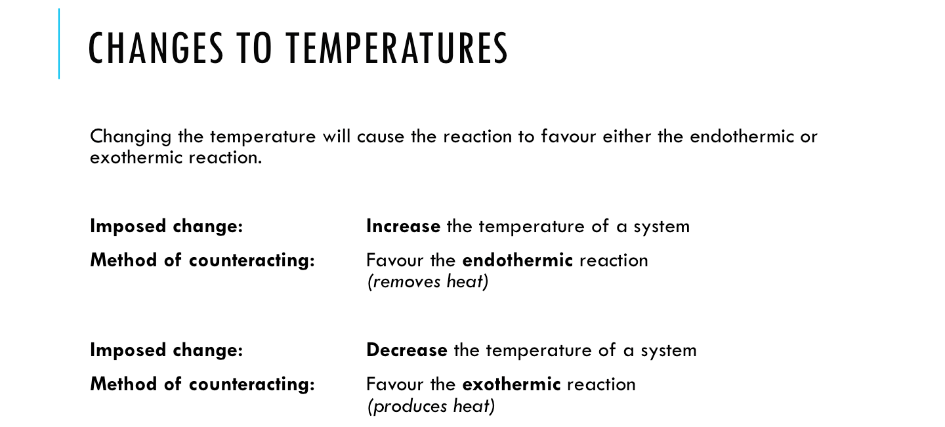

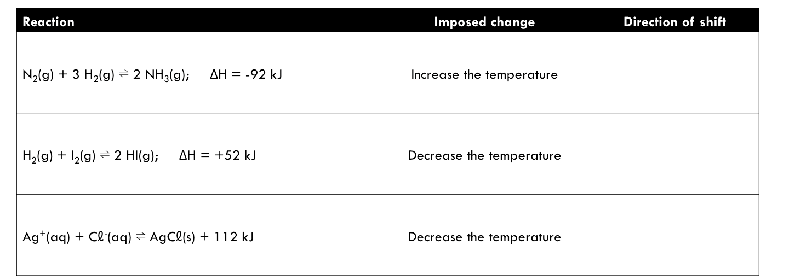

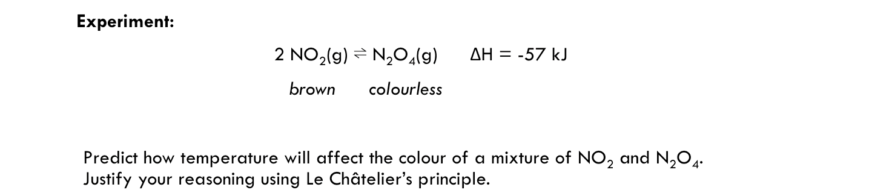

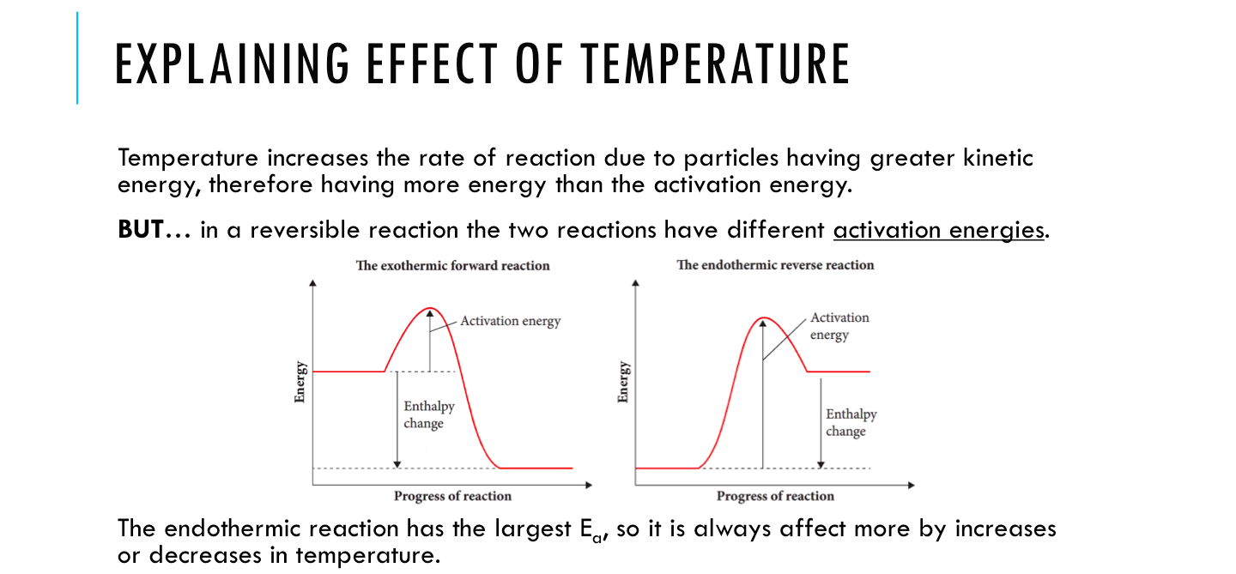



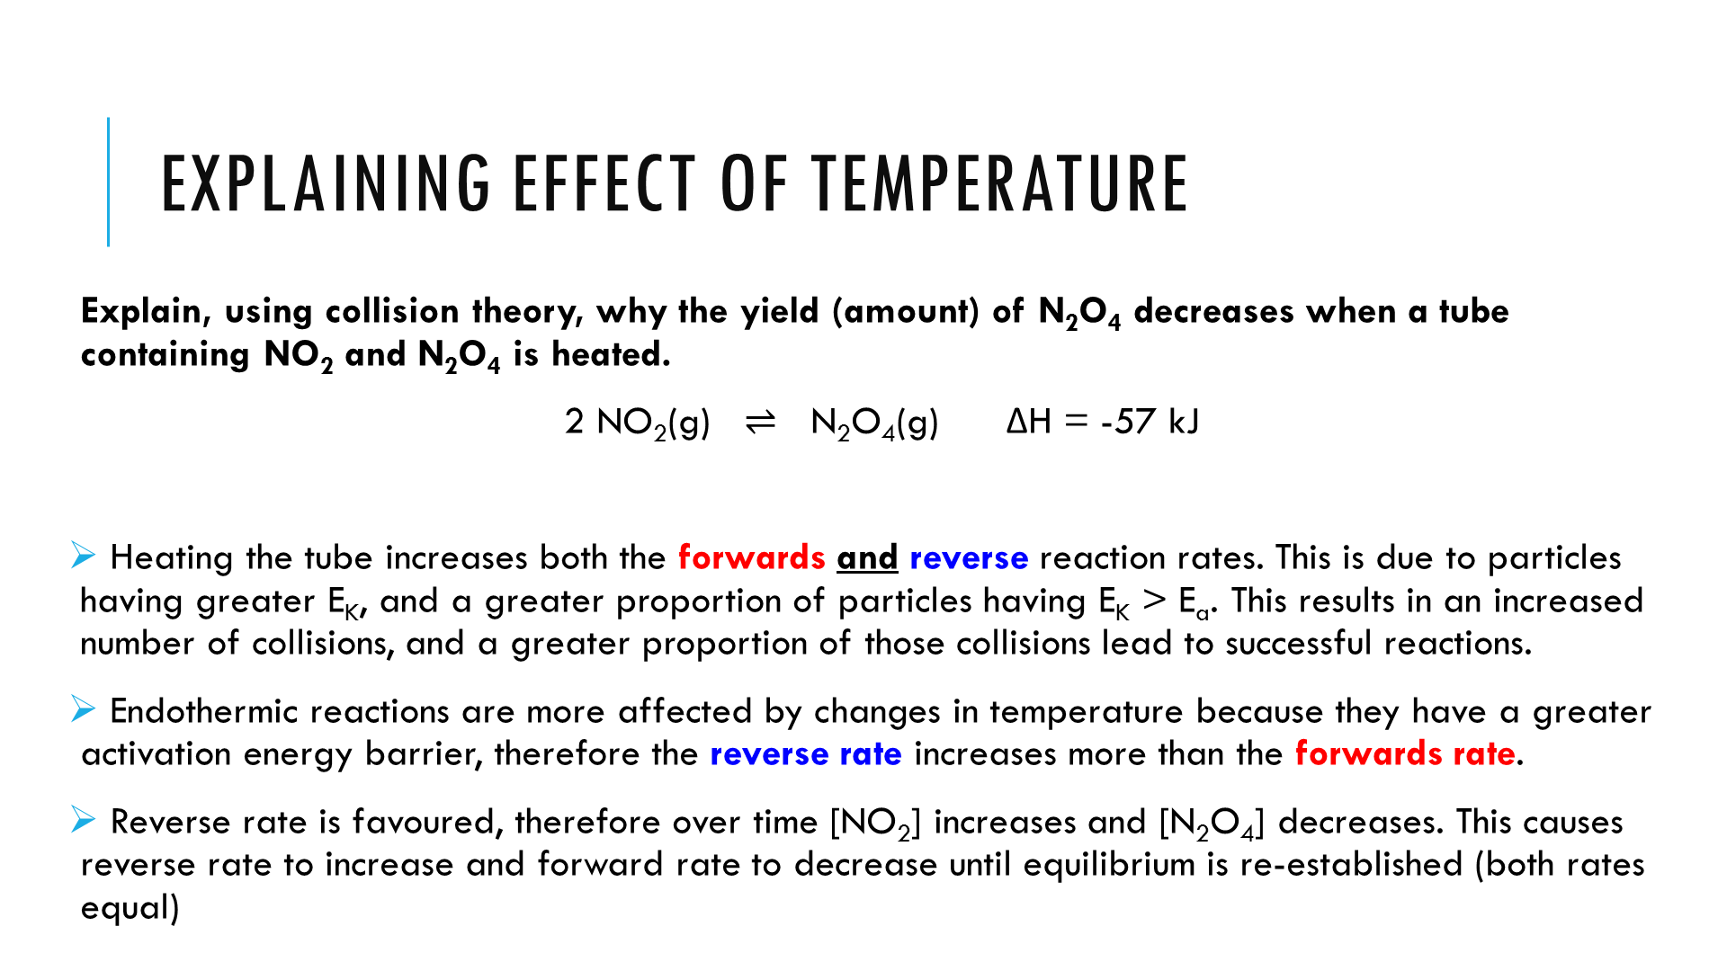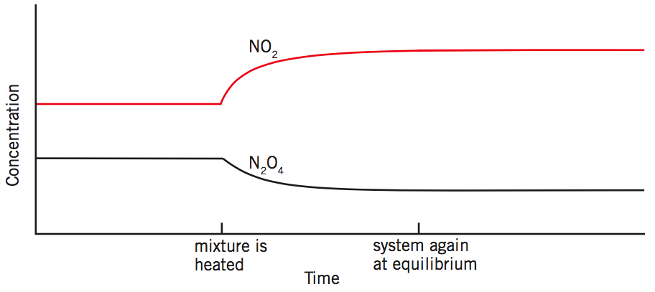

**Pay attention to the following:**

* Unlike the other sets of graphs, there is **no change** to the **initial** concentrations*. The reactants and products will be hotter or colder, but not more or less concentrated.
* **Both** reaction rates will be affected by temperature (i.e. both increase or both decrease). The endothermic reaction will change more than the exothermic reaction. This can also be figured out by thinking of the direction of shift using L.C.P.

*\*Advanced note: If it was a graph of pressure* *over time then there would be an initial change because pressure of gases is inversesly proportional to temperature.*

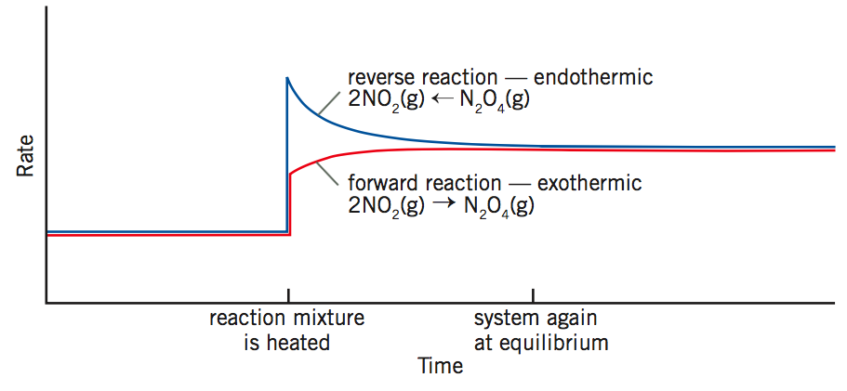

**Changes in temperature:**

**Predict** whether a decrease in temperature will increase or decrease the yield of HI(g). Justify your answer using **Le Châtelier's Principle**. (Yield = Amount)

H2(g) + I2(g) ⇌ 2 HI(g) ΔH = +52 kJ mol-1

time

time

**Thought process you should follow:**

1. How does a decrease in temperature affect reaction rates?
2. Which reaction (forward or reverse) is affected *more* by changes in temperature?
3. Which reaction is favoured after the temperature changes? What would that mean about the concentration of reactants and products over time?
4. What mole ratio do I need to show while equilibrium is being re-established? How will that affect my curves?

Reaction rates

Concentration

Temperature decrease

New equilibrium

New equilibrium

Temperature decrease

**Changes in temperature:**

**Predict** whether an increase in temperature will increase or decrease the yield of H2(g). Justify your answer using **Le Châtelier's Principle**.

C(s) + H2O(g) + 131 kJ ⇌ CO(g) + H2(g)

time

time

Reaction rates

Concentration

Forwards reaction rate

Reverse reaction rate

Temperature increase

Equilibrium re-established

Equilibrium re-established

Temperature increase

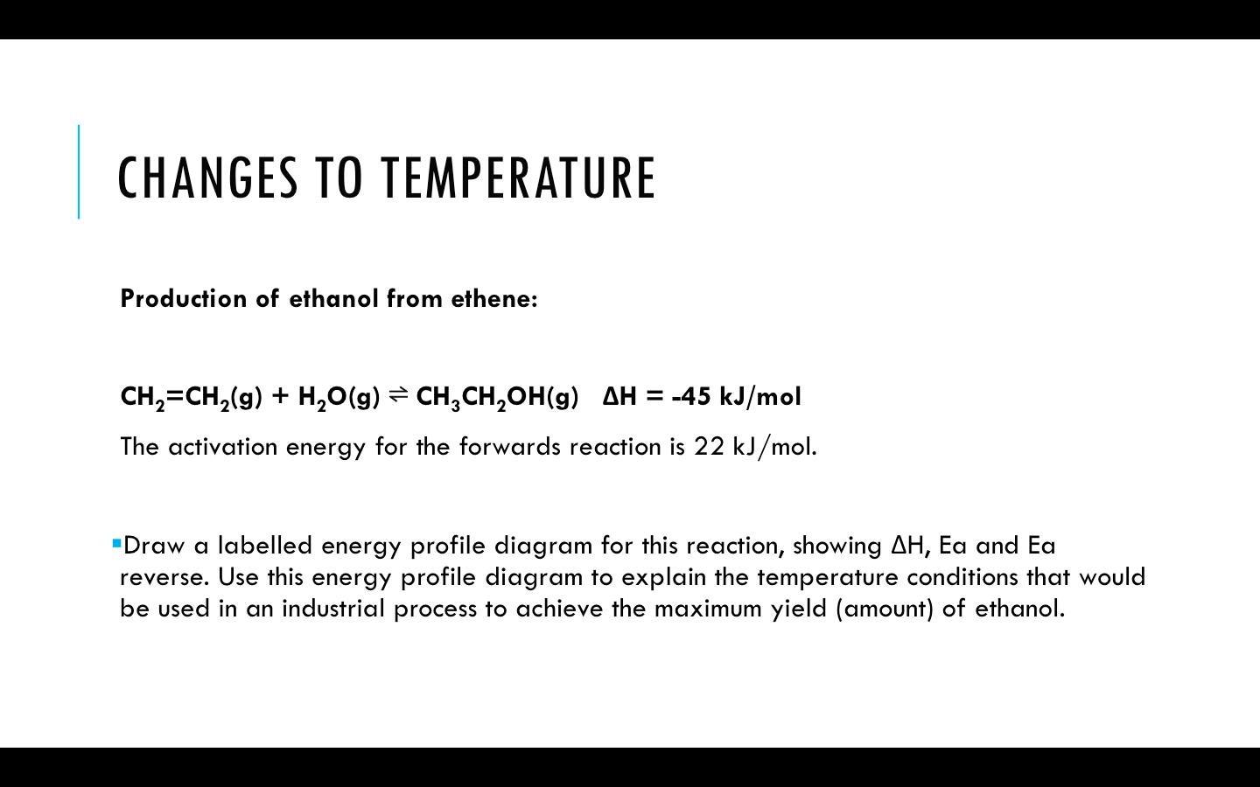

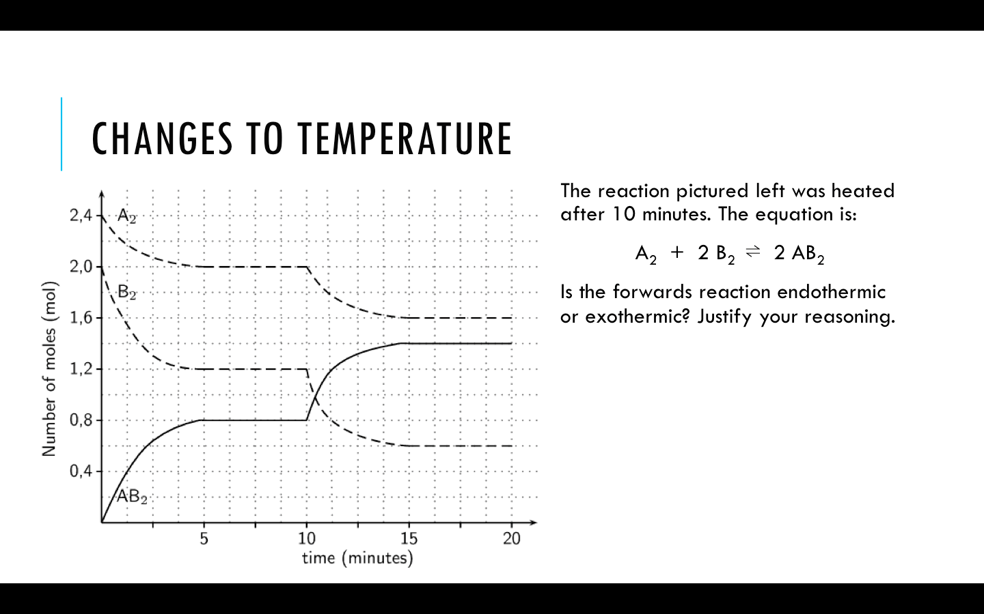

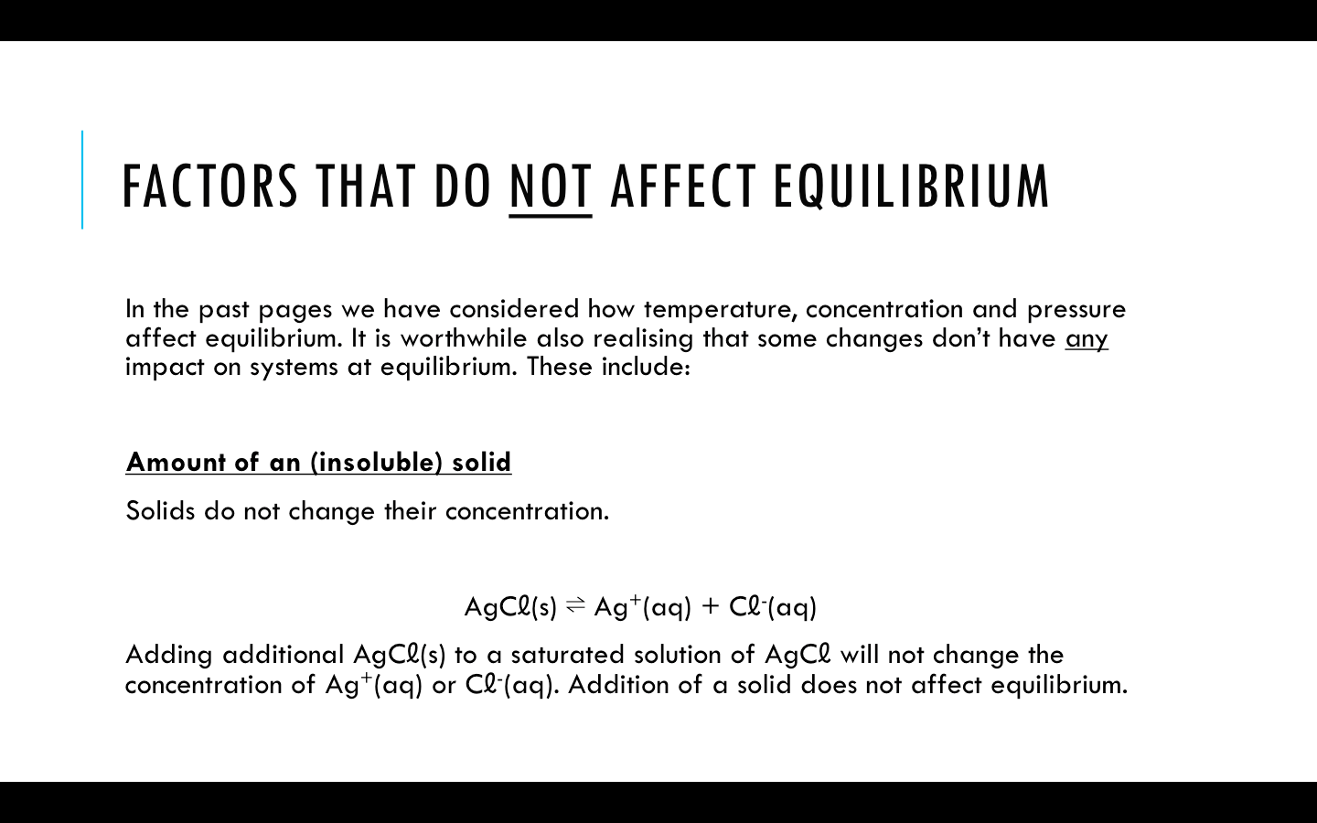

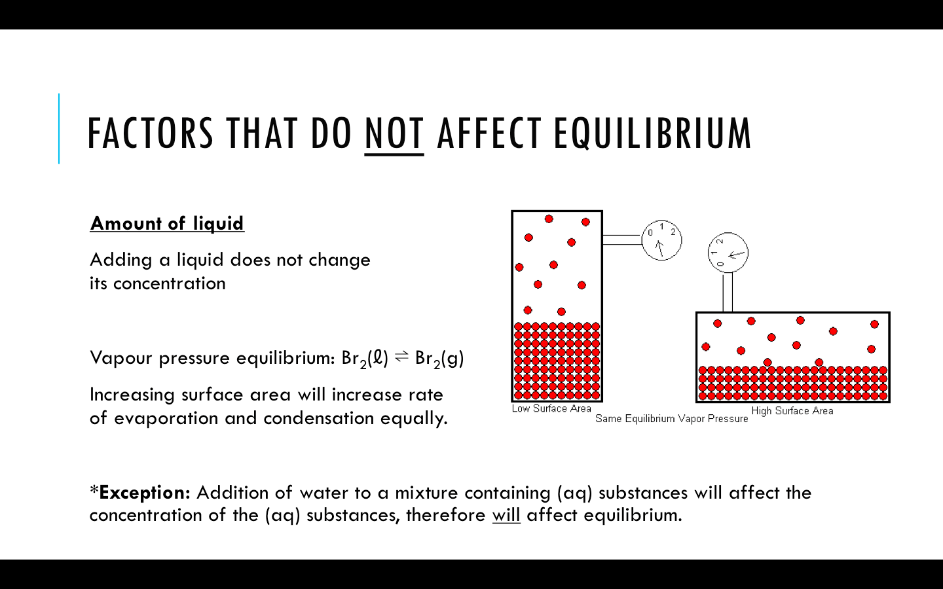

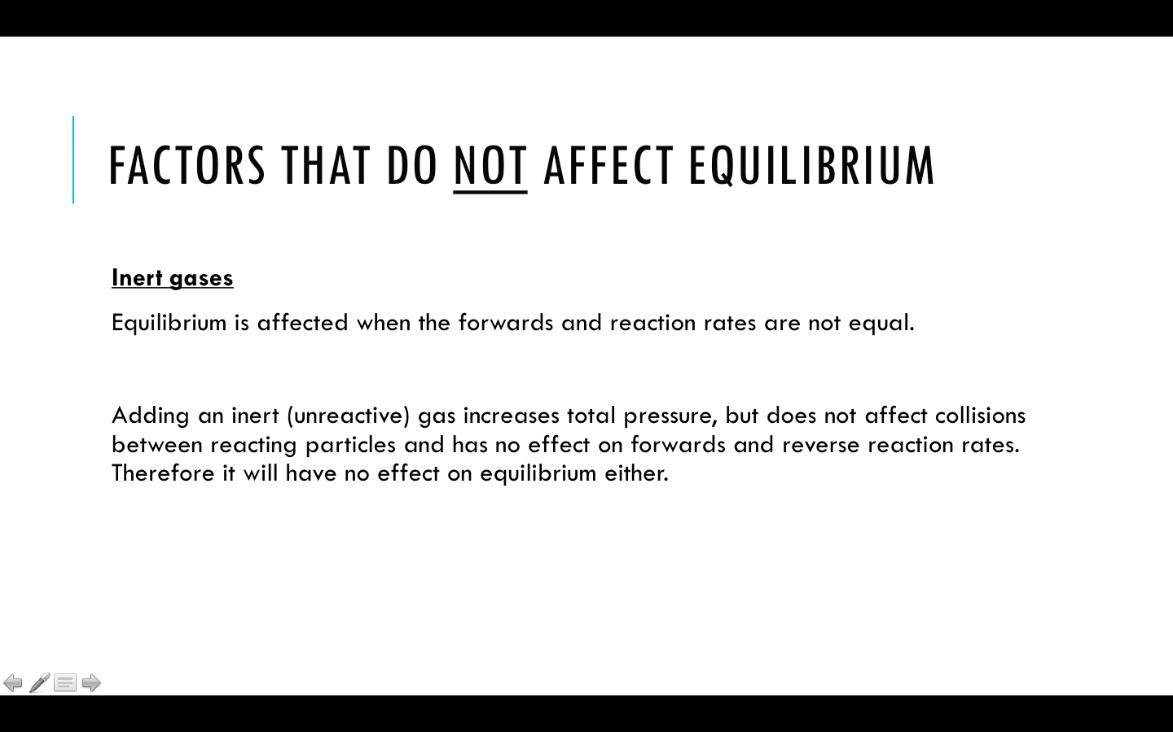

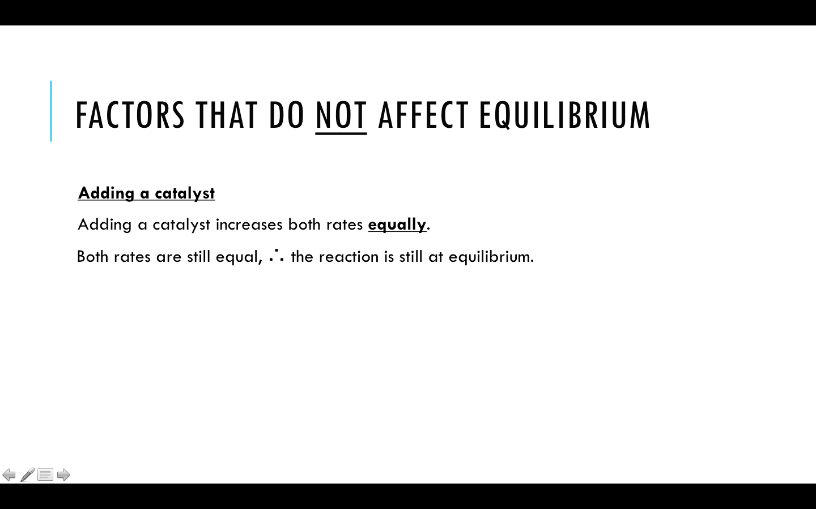

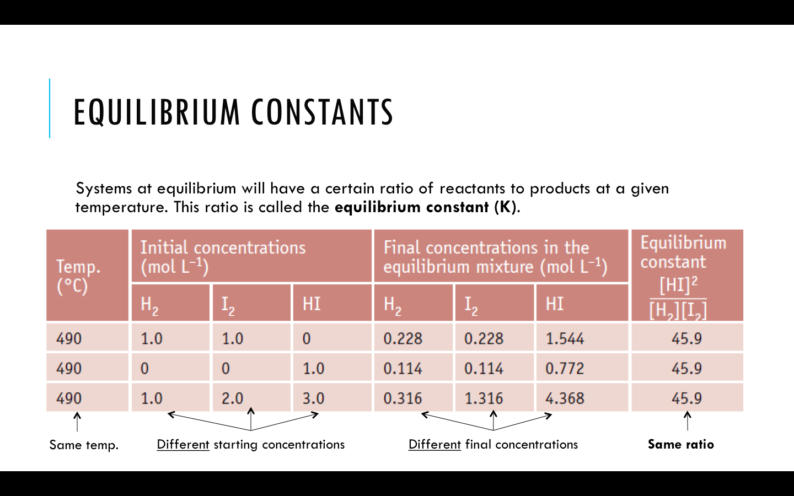

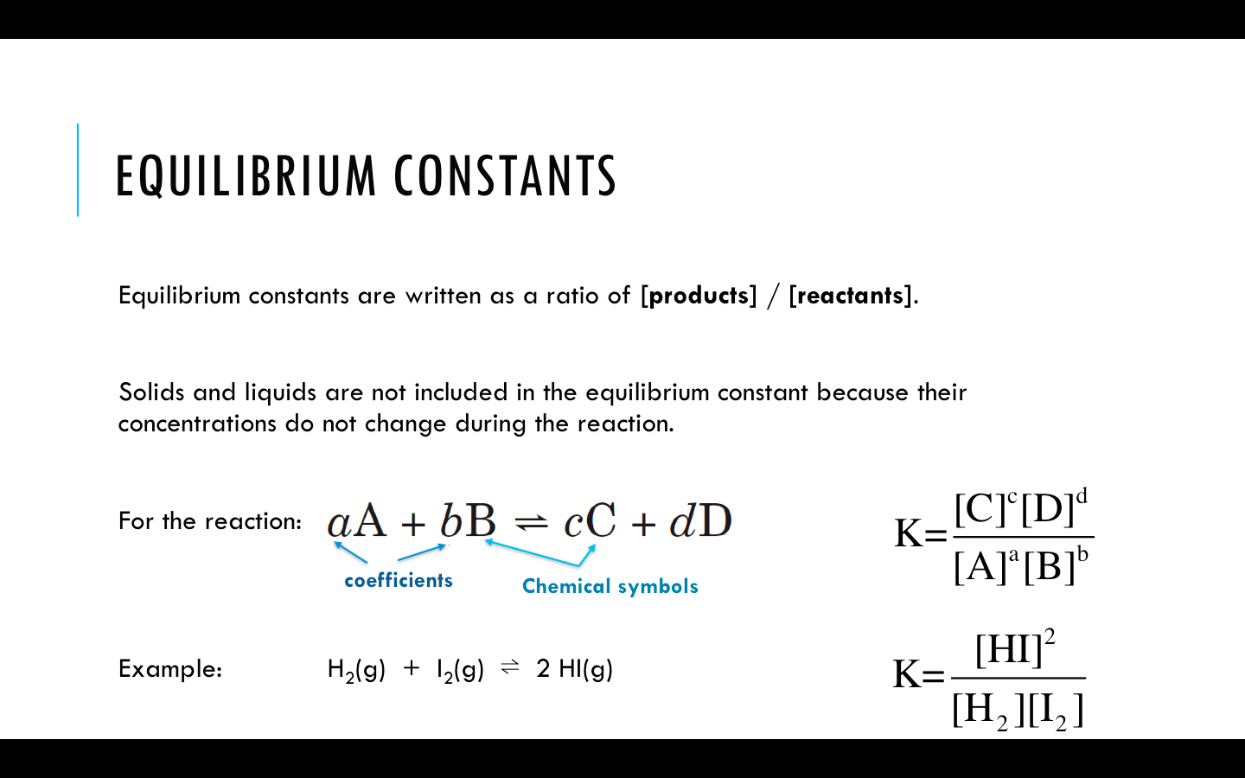

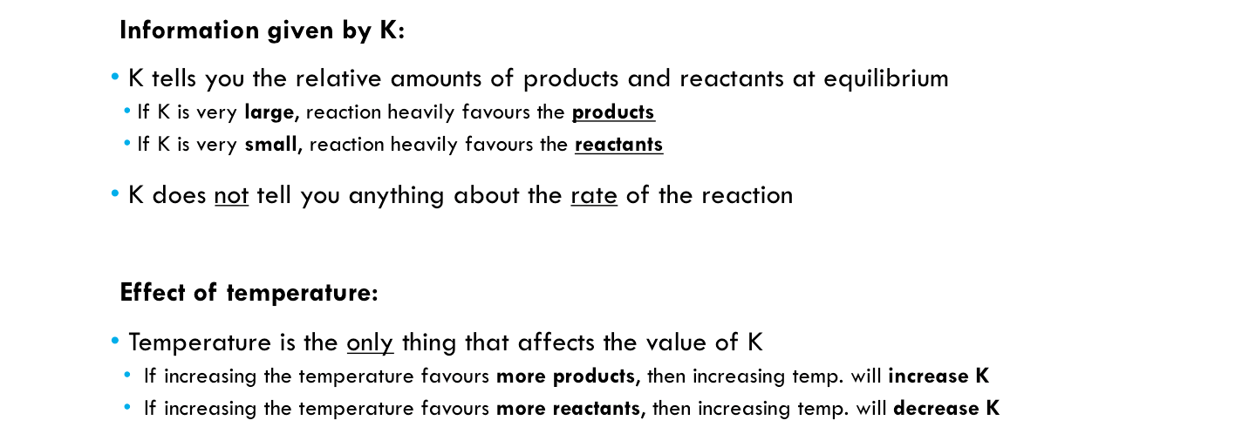

***Past WACE and TEE questions about equilibrium constants: (2000-2014)***

|  |  |
| --- | --- |
| ***Equation*** | BaSO4(s) ⇌ Ba2+(aq) + SO42-(aq) |
| ***Equilibrium constant expression*** |  |

|  |  |
| --- | --- |
| ***Equation*** | 2 CrO42-(aq) + 2 H+(aq) ⇌ Cr2O72-(aq) + H2O(ℓ) |
| ***Equilibrium constant expression*** |  |

|  |  |
| --- | --- |
| ***Equation*** | Ca(HCO3)2(s) ⇌ CaO(s) + 2 CO2(g) + H2O(g) |
| ***Equilibrium constant expression*** |  |

|  |  |
| --- | --- |
| ***Equation*** | Co(H2O)62+(aq) + 4 Cℓ-(aq) ⇌ CoCℓ42-(aq) + 6 H2O(ℓ) |
| ***Equilibrium constant expression*** |  |

|  |  |
| --- | --- |
| ***Equation*** | 2 H2O(ℓ) + 4 Au(s) + O2(g) + 8 CN-(aq) ⇌ 4 Au(CN)2-(aq) + 4 OH-(aq) |
| ***Equilibrium constant expression*** |  |

|  |  |
| --- | --- |
| ***Equation*** | PbCℓ2(s) ⇌ Pb2+(aq) + 2 Cℓ-(aq) |
| ***Equilibrium constant expression*** |  |

|  |  |
| --- | --- |
| ***Equation*** | Fe(H2O)5NCS2+(aq) + H2O(ℓ) ⇌ Fe(H2O)63+(aq) + NCS-(aq) |
| ***Equilibrium constant expression*** |  |
| ***Equation*** | 2 NOCℓ(g) ⇌ 2 NO(g) + Cℓ2(g) |
| ***Equilibrium constant expression*** |  |

|  |  |
| --- | --- |
| ***Equation*** | 2 HI(g) ⇌ H2(g) + I2(g) |
| ***Equilibrium constant expression*** |  |

|  |  |
| --- | --- |
| ***Equation*** | 4 NH3(g) + 3 O2(g) ⇌ 2 N2(g) + 6 H2O(g) |
| ***Equilibrium constant expression*** |  |

|  |  |
| --- | --- |
| ***Equation*** | Cℓ2(g) + H2O(ℓ) ⇌ HOCℓ(aq) + H+(aq) + Cℓ-(aq) |
| ***Equilibrium constant expression*** |  |

|  |  |
| --- | --- |
| ***Equilibrium process*** | Vaporisation of water |
| ***Equation*** |  |
| ***Equilibrium constant expression*** |  |

|  |  |
| --- | --- |
| ***Equilibrium process*** | Dissolution of ammonium chloride |
| ***Equation*** |  |
| ***Equilibrium constant expression*** |  |

***Industrial Applications of Equilibrium***

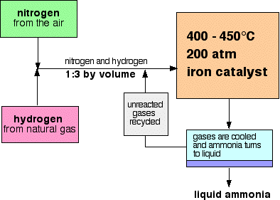**HABER PROCESS**

N2(g) + 3 H2(g) ⇌ 2 NH3(g) ΔH = -92 kJ

**Conditions used:**

* Moderate temp (400-450 °C)
* High pressure (200 atm)
* Iron-based catalyst
* **Temperature**

High temperatures would increase the **rate** of ammonia production due to particles having greater kinetic energy. More particles would have energy > Ea, so a greater proportion of collisions would be successful.

Low temperatures would increase the **equilibrium yield** of ammonia. According to Le Châtelier's principle, decreasing the temperature would favour the exothermic reaction, which in this case is the forwards reaction.

The Haber process uses moderate temperatures of 400-450 °C. This is used as a compromise between reaction rate and yield. Higher temperatures would have too low of a yield, whereas lower temperatures would have too low of a reaction rate.

* **Pressure**

High pressures would increase the **rate** of production due to more collisions between gas particles.

High pressures would also increase the **equilibrium yield** of ammonia. According to Le Châtelier's principle, high pressures favour the side of the reaction with the least moles of gas, which in this case is the right hand side (4 moles 🡪 2 moles).

The chosen pressure of 200 atmospheres is high to maximise rate and yield. Higher pressures are possible and would further increase the yield and reaction rate, but higher pressures are too expensive to maintain and pose additional safety risks and this makes it economically unviable.

* **Catalyst**

An iron-base catalyst is used. Catalysts increase the rate of reaction by providing an alternate reaction pathway with a lower activation energy. This means that more particles at a given temperature can react because they have energy greater than the catalysed activation energy.

Catalysts do not affect equilibrium yield because the increase forward and reverse rates equally. This means that catalysts can increase rate without negatively affecting yield, giving them an economic benefit.

* **Removing the ammonia and recycling the reactants**

In the final stage of the process the ammonia is liquefied and removed. The unreacted N2 and H2 are re-added to the reaction mixture to keep reacting.

Removing the ammonia prevents the reverse reaction from happening, stopping the NH3 from reacting again to make N2 and H2.

When the unreacted gases are added back into the reaction mixture they increase the concentration of reactants and cause the reaction to shift to the right, allowing more NH3 to be produced.

**CONTACT PROCESS**

The Contact Process is used for the manufacture of sulfuric acid. It involves multiple steps.

|  |  |  |  |  |  |  |  |  |
| --- | --- | --- | --- | --- | --- | --- | --- | --- |
| S(s) |  | SO2(g) |  | SO3(g) |  | H2S2O7(ℓ) |  | H2SO4(ℓ) |

**Step 1:** Sulfur is combusted in the presence of oxygen. S(s) + O2(g) → SO2(g)

**Step 2:** Sulfur dioxide is oxidised to form sulfur trioxide. This is a reversible, exothermic reaction.

SO2(g) + O2(g) ⇌ 2 SO3(g) ΔH = -196 kJ

**Conditions used in Step 2:**

* Moderate temp (400-500 °C)
* Low pressure (1 atmosphere)
* Vanadium(V) oxide (V2O5) catalyst
* **Temperature**:

*[The explanation for why a moderate temperature is used in the Contact Process is virtually identical to the explanation for temperature in the Haber Process, previous page. Both reactions are exothermic, so yield is decreased at higher temperatures. A moderate temperature is needed to obtain a satisfactory balance between yield and rate]*

* **Pressure:**

High pressures would increase the **rate** of production due to more collisions between gas particles.

High pressures would also increase the **equilibrium yield** of sulfur trioxide. According to Le Châtelier's principle, high pressures favour the side of the reaction with the least moles of gas, which in this case is the right hand side (2 moles 🡪 1 mole).

Despite this, the actual pressure used is quite low. This is because the reaction actually has quite a high yield and rate at atmospheric pressures. High pressures are expensive to maintain and add safety risks, so there is no economic benefit in increasing the pressure above 1 atmosphere.

* **Catalyst:**

*[Once again, this explanation would be identical to the one given for the Haber process, only it would mention the V2O5 catalyst instead of the iron-based catalyst]*

**Step 3 & 4:** The SO3(g) cannot be directly reacted with water to form H2SO4(ℓ) because the reaction is uncontrollable and forms a fog of sulfuric acid.

Instead, the SO3 is reacted with concentrated H2SO4 to form an intermediate, H2S2O7(ℓ) (oleum). The oleum can then be safely reacted with water to produce concentrated sulfuric acid.

**Step 3:** SO3(g) + H2SO4(ℓ) → H2S2O7(ℓ)

**Step 4:** H2S2O7(ℓ) + H2O(ℓ) → 2 H2SO4(ℓ)

Past exam question (TEE 2008):

Nickel ores are predominantly sulphides and oxides. The Mond process is an industrial process used to extract nickel from nickel oxide ores. It involves three steps, with each step conducted at moderate pressures.

*Step 1:* Nickel oxide is reacted with hydrogen at 200 °C to produce impure nickel metal and water. The impurities present include iron and cobalt. This step goes to completion.

*Step 2:* The impure nickel is converted into gaseous nickel carbonyl, Ni(CO)4, using an excess of carbon monoxide at 50-80 °C. The reaction is exothermic.

*Step 3:* The nickel carbonyl is separated from the residue and passed over platinum heated to 220-250 °C. The nickel carbonyl decomposes, giving pure nickel and carbon monoxide. The carbon monoxide is recovered for purifying further batches of nickel.

Explain the conditions used to maximise yield in the Mond process in terms of reaction rates and equilibrium.

**HOMEWORK**

|  |  |  |  |  |  |  |  |  |  |  |  |  |
| --- | --- | --- | --- | --- | --- | --- | --- | --- | --- | --- | --- | --- |
| **Source** | **Topics** | **Set/**  **Chapter** | **Questions to complete** | | | | | | | | | |
| Essential Chemistry | Reaction rates & collision theory | EC Set 1 | … | 3 | 4 | 5 | … | 9 | 10 | 11 |  |  |
| Characteristics of systems in equilibrium | EC Set 2 | 1 | 2 | 3 | 4 | 5 |  |  |  |  |  |
| Changes to concentration | EC Set 2 | 6 | … | 9 | 10 | 11 |  |  |  |  |  |
| Changes to pressure and temperature | EC Set 2 | 12 | 13 | 14 | 15 | 16 |  |  |  |  |  |
| Equilibrium constants | EC Set 2 | 7 | 8 |  |  |  |  |  |  |  |  |
| Industrial processes | EC Set **21 (page 172)** | 14 | 15 | 16 | 17 |  |  |  |  |  |  |
| Past Exam Questions | Collision theory, reaction rates, energy profile diagrams | Section 1 | [MC] | Pg: | 2 | 3 | 4 | 5 |  |  |  |  |
| [SA] | Pg: | 6 | 7 | 8 |  |  |  |  |  |
| Systems in equilibrium, Le Châtelier's Principle, Equilibrium Expressions | Section 2 | [MC] | Pg: | 9 | 10 | 11 | 12 | 13 | 14 | 15 | 16 |
|  |  | 17 | 18 | 19 | 20 |  |  |  |  |
| [SA] | Pg: | 21 | 22 | 23 | 24 | 25 | 26 | 27 | 28 |
|  |  | 29 | 30 | 31 | 32 | 33 | 34 | 35 | 36 |
|  |  | 37 | 38 |  |  |  |  |  |  |
| Industrial and environmental applications of rates and equilibrium | Section 3 | [SA] | Pg: | 39 | 40 | 41 | 42 | 43 | 44 | 45 | 46 |
|  |  | 47 | 48 | 49 | 50 | 51 | 52 |  |  |